Home Learning Menu
Class 4O
Summer 2020
Mathematics
Number | Measure | Challenge | Online Resources
Double the amount of each item on a receipt and calculate the new total. | Measure the height of your family members and round their height to the nearest 10cm. | Choose 3 things that you want to watch on television and calculate how long it will take. | Hwb
Play the ‘bang, bang!’ multiplication game with a member of your family | Create your own exercise circuit and record how long it takes to complete each day. | What is the largest calculation/answer you can make using the numbers in your date of birth?
Roll a dice and keep doubling the number. What is the largest number you can reach? | Estimate and then weigh 10 items of food from your food cupboard. | How many 4, 5, 6, and 7 digit numbers can you make with a mobile phone number? | 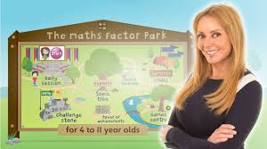

Language
Reading | Oracy – record it if you can! | Writing task | Online resources
Read a blurb and create a new front cover for the book. | Carry out an interview with your favourite sports star or popstar. | Write a description of your favourite fictional character without using their name. | 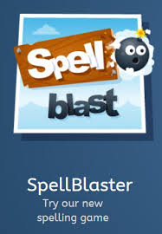Hwb
Read your favourite book for 20 minutes without stopping! | Record a presentation on something that you are interested in. | Write a newspaper report on a topic of your choice. | Listen to an audiobook using the free resources on Audible
Keep a reading record of all the books that you read. | Act out a scene from your favourite film | Write a diary entry of your favourite day since you have been at home – or keep a daily diary.

Spelling

SWST spelling – see powerpoints of spelling patterns on homework page on school website – all patterns from Level 2 - 6

Topic
Art | History | Geography
Draw something you can see in the garden – a plant or flower – try sketching using shading and delicate lines. | Welsh History – Find out about a place in Wales you don’t know much about but has lots of interesting history i.e Snowdonia National Park, Pembrokeshire? | Draw a map of Wales and create a key of known places and towns.  How would you describe Wales as a country? How does it compare to other countries?

Can you brainstorm your ideas on ‘Wonderful Wales’ and create a mind map or circle diagram to show what we could learn about and what you would like to learn about?
+ Mymaths and Hwb
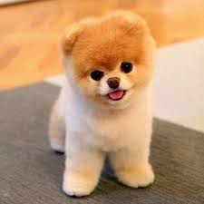
Thank you so much for all your work you have shared with me – you are all fantastic!
I will look forward to seeing more on Hwb, one drive, email or Seesaw!
Keep Safe
Miss Owen

