Homework 13.9.19
Read the sentences then try to work out what punctuation is needed. Rewrite each sentence in blue pen using school handwriting.

- the boy looked out of the window he wished he could go out to play

- Matthew turned on the television but there was nothing to watch

- t was so unfair daniel was not allowed to play on the xbox until he did his homework

- lily was really looking forward to the weekend because she could play with her friends

- keeley was excited because her cat was going to have kittens she wondered how many there would be

These sentences all need capital letters, commas and full stops.

Homework 13.9.19
Read the paragraph and then try to work out what punctuation and capital letters are needed. Underneath the paragraphs is the punctuation you need to use. Rewrite the passage in blue pen using school handwriting.

something woke scott and he lay listening to the wind buffeting the house and rattling the windows he got out of bed and pulled the curtains aside peering into the unfamiliar darkness it was their first night in the new house lightning flashed and in that instant he saw a figure hurrying from the house towards the gate which led up onto the moors
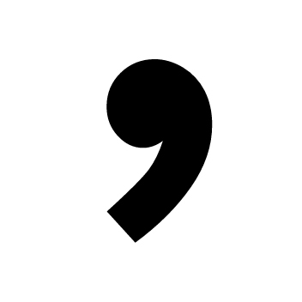

Homework 13.9.19
Read the paragraphs and try to work out what punctuation is needed. Underneath the paragraphs is the punctuation you need to use. Rewrite the passage in blue pen using school handwriting.

Deep in the forest the magical lake glittered in the early morning sun Tall trees stood like silent guards around the water’s edge thick branches keeping out all but the most determined of visitors In the middle of the lake a purple mist swirled around The figure watching from the bank knew just what the mist concealed

Avalon the woman whispered Her dress was long and black decorated with dark jewels that seemed to greedily draw in the light from around her Although the early autumn air was cold the woman wore no cloak and not a single shiver crossed her pale skin

Homework 13.9.19
Read paragraphs and then try to work out what punctuation is needed. Rewrite the passage correctly in blue pen using school handwriting.

The boy ran down the rain-soaked street weaving between abandoned cars He crouched behind one of the vehicles and tried to quiet his laboured breath at first he heard nothing but then behind the noise of the falling rain he made out another sound one that in recent months he had learned to fear The high-pitched whine was getting louder Did that mean the Drones had tracked his scent The boy forced himself to his feet pushing the long black hair out of his eyes and set off down the road again He didnt look back if there was anything behind him he would rather not know
He ducked through the broken door of one of the shops lining the street and ran between shelves stocked with now useless electronic devices Vaulting over a counter at the far end of the shop he grabbed the handle of a door marked Staff Only silently praying that it wasnt locked the handle turned and he stepped into
the gloom of the room beyond As the door closed again he was plunged into darkness

