Space (Inventors and Inventions) – Home Learning (Week 8) 15th June 2020
Read the book called Back To Earth With A Bump LINK
and write a book review. Complete the PowerPoint on Google Classroom.
 | Weekly Tasks
Numeracy-  - Complete the assigned My Maths tasks linked to our previous class work. (fractions x 7)  - Bitesize link (fractions)  https://www.bbc.co.uk/bitesize/topics/zhdwxnb  - Times tables practice and other skills using J2Blast (Hwb) or  http://www.maths-games.org/times-tables-games.html |  |  |  | English (Spellings/Handwriting/Comprehension)  - Boggle word challenge – Week 8. How many words (of 3 or more) can you find in the letters given? 5 Dojos if you can work out the 9 letter word?  - Practice the prefix rules of im, dis, in and il pattern spellings  https://spellingframe.co.uk/spelling-rule/11/4-More-prefixes-1-of-3  The Solar System Comprehension (see sheet on website. Answers also available)  - Create an advert for your new space buggy based on your Science project. Use the guidance sheets to help you include all the important features you need to make your advert stand out. Use the guidance (PowerPoint and BBC BITESIZE) to help you create it.  https://www.bbc.co.uk/bitesize/articles/zy8m8hv
Activities
Create |  | PSHE | Science |  | Welsh | Topic
Create a planet or planet solar system.  Watch this for ideas!!  https://www.youtube.com/watch?v=Cxv_kxq5vlg  Use your art skills to create your favourite planet or indeed an entire solar system. Send a photo and description of your planet. |  | Wellbeing Calendar - Link  https://www.elsa-support.co.uk/wp-content/uploads/2020/05/Wellbeing-calendar-for-June.pdf  Choose one a day or dip in when you need. Lots of fun activities to keep us smiling. | Design a space buggy for the Planet Mars  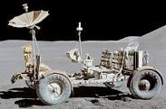  Research the information needed to help you design a vehicle that will you’re your buggy survive the planet Mars. Use Hwb or sheet provided. |  | Duolingo activities.  Numbers 1  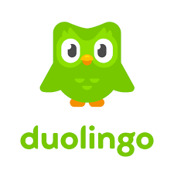  Keep up your welsh skills using our new school app. | SPACE Inventors and Inventions Activity Grid  Choose one activity from the topic grid to complete each week.

