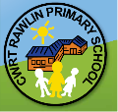
Cwrt Rawlin Primary

Ambassador Newsletter
Football  &  Rugby | Football: We played football at Gwindy. We ate on the concrete and had loads of fun.  Everyone played 7 matches each but the goalie played all 9. Zach H lobbed the goalie from the half way line! Wow!  Rugby: We have played three games so far this term. We beat Twyn, lost to Caerphilly YC and we played some mixed team fun games which we won. Everyone played their best and we are looking forward to the next game. We are hoping for better weather next time!
Netball | We have attended two different netball tournaments this year so far. We have played lots of different schools from around Caerphilly. We are looking forward to our next game and the amazing netball has been training very hard.  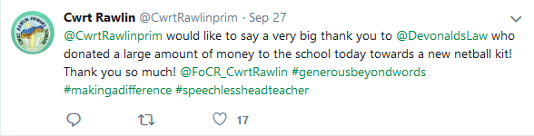 | 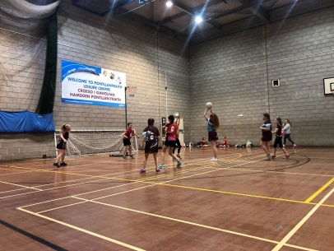
Harvest | Very kindly, 3/4H led our 2019 Harvest assembly. Two men from the Caerphilly Food bank came into our harvest assembly to talk to us about their work. Every class had a role in the assembly either to sing a song or read a poem. | 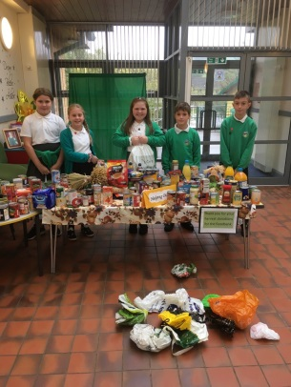
Bronze Cymraeg Campus  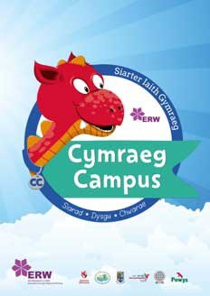 | We proudly acheived the bronze campus award in school! For this award the Criw Cymraeg took the assessor around the school to see all the amazing Welsh displays. She spoke to the children in Welsh and everyone confidently replied in Welsh. Our next goal is to win the silver award! Da iawn pawb! | 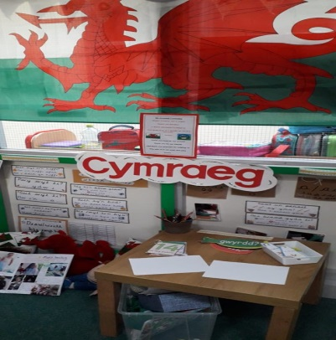
Friends  Of  Cwrt Rawlin  ( FoCR) | The school disco is on Thursday 14th of November. There are lots of choices of sweets to buy, glow sticks and amazing music to bust some moves too! | 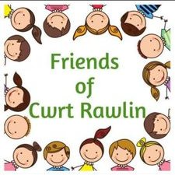

Breaking News.......
There may be a free homework weekend every month, this was a suggestion from some parents at the coffee morning, and we think it is a VERY good idea (HOORAY) but we need to talk to the teachers first!

Thank you for reading our first Newsletter...... watch out for the next update in November!

Written by all the Y6 Ambassadors (edited by Joshua F and Millie E)

