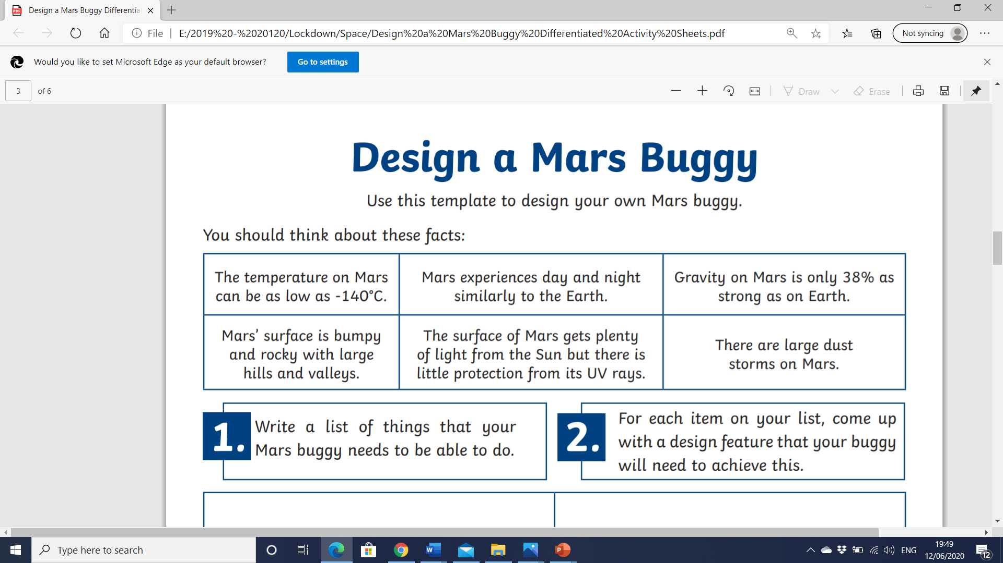

**INSTRUCTIONS**

1. Read the important information about the planet Mars.
2. Research the types of materials used for space buggies.
3. Use your Science knowledge to help you choose the best design.
4. Record your findings on this piece of paper using your ICT skills to show me what you have found out and your ideas.
5. Create your finished design using paper, Hwb or on here to make a Computer aided design.