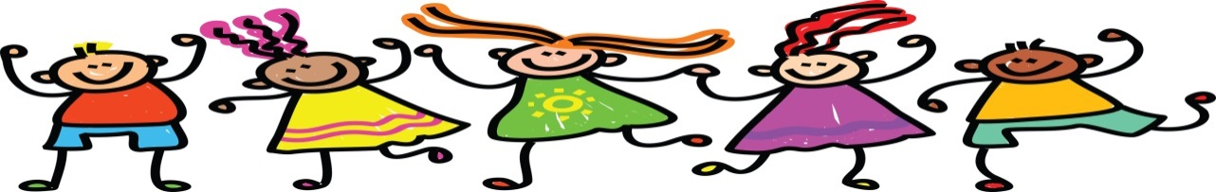
b

R/1 Class Newsletter - Week 1
Week Commencing: 06.1.20
Practise – Please can you keep practising number formation to 20 with the children at home. Please can you practise letter formation at home. Our cursive style handwriting can be found at the front of the school handwriting books.Timetable - PE days – Tuesday – indoor kits. Wednesday – outdoor kits. Forest school – Thursday – welly boots and waterproofs can be brought in and kept in school. Reading books –brought into school everyday. Year 1 spellings – Monday. Please can all PE bags have name labels. Please ensure that they are left in school.

Many thanks for your continued support and cooperation.
Miss Hollister Miss Landrygan Mrs Wiltshire Mrs Talbot Miss Gasson
Theme of the week: Super Stars
This week the children have been busy learning about our new topic ‘Super Stars’. This topic has been chosen by the children and we will be learning amazing facts and information about princess’ and super heroes. The children have been finding words in books and have practised the words; LOOK, AT ME, THE AND. with the teachers in class. Please can you help the children read these words and try and find them in any books at home also.
Our sound/letter of the week:
This week we have been working on lots of new key letters in class. This week the children have been looking at the letter ‘d’ and the blend ‘cr’. We have also been writing about our holiday news.
Our New Topic
Our new topic is ‘Super heroes and Princess’’. If you have anything at home (linked to this topic) that you would like to donate (including old super hero/princess bedding/material) to our class, we would be very grateful.

Welsh for the week:
The children are practising the sentence Beth wyt ti’n hoffi with the answer dw i’n hoffi ….
Belongings
This time of the year we have hats, gloves etc brought in….please can you label all belongings. Please can all PE clothes including footwear have name labels. If the girls wear tights to school please can you also put a pair of socks in their PE bags too.
Creative area
This week some of the children have been busy painting and collaging super star pictures.
Maths for the week:
This week the children have been looking at number bonds to 10 and 20. The children have been adding two numbers together 4+6 = 10, 10+0= 10. 13+7 = 20 15+5 = 20. Maths word challenges - the children have also been given maths challenges linked to our new topic.

