Transport (Inventors and Inventions) – Home Learning (Week 9) 22nd June 2020
Read the book called Victorian Venture and learn about the inventions and the life of the Victorians.
https://content.twinkl.co.uk/resource/78/f3/t2-or-600b--history-hackers-victorian-venture-ebook-pdf.pdf?__token__=exp=1592775258~acl=%2Fresource%2F78%2Ff3%2Ft2-or-600b--history-hackers-victorian-venture-ebook-pdf.pdf%2A~hmac=983ee7658e1a577d6c4098e597b4f8db46086e10d9ecdf8d5288ac88d62fdcf5
 | Weekly Tasks
Numeracy-  - Complete the assigned My Maths tasks linked to our previous class work. (addition and subtraction mental methods x 4)  - Bitesize link (addition and subtraction)  - https://www.bbc.co.uk/bitesize/topics/zy2mn39  - Times tables practice and other skills using J2Blast (Hwb) or  http://www.maths-games.org/times-tables-games.html |  |  |  | English (Spellings/Handwriting/Comprehension)  - Boggle word challenge – Week 9. How many words (of 3 or more) can you find in the letters given? 5 Dojos if you can work out the 9-letter word?  - Practice tion, sion, cian and ssion words.  https://spellingframe.co.uk/spelling-rule/61/14-Endings-which-sound-like--spelt%E2%80%93tion%E2%80%93sion%E2%80%93ssion%E2%80%93cian-(2-of-2)  - Write a story about ‘The Mobile House’ or ‘Escape from Jurrasic’. See Story toolbox to help you.  - Tesla comprehension – read the PowerPoint and complete the comprehension.  - Jack’s riddle challenge on Google Classroom/Website. How many can you work out?
Activities
Citizenship |  | PSHE | History |  | Welsh | Topic/Science
Complete a kindness wheel.  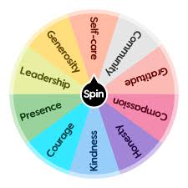  Complete the wheel worksheet or make your own wheel showing who you have been kind to and what you did. Kindness can be helping, making, complimenting, communicating, affection. |  | SPORTS WEEK DIARY  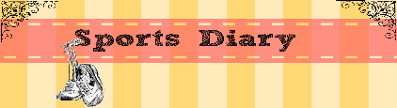  Using as many different exercise wheel inventions as possible, make an exercise diary recording all the different transport that you can. Monday can be scooter. Tuesday could be your bike, Wednesday could be roller skates etc.. | The Wheel  Create a fact file/PowerPoint about the history of the wheel.  Watch this to get you thinking but do more research from other places.  https://www.youtube.com/watch?v=XzG1aPw7YBc&t=22s  You can include headings such as Who invented it? When was it invented? Where was it invented? What uses do wheels have? Types of wheels? How do wheels work? Life without wheels? Don’t forget to include photos. |  | Duolingo activities.  Animals  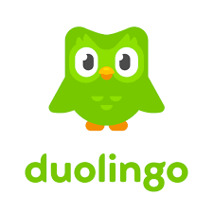  Keep up your welsh skills using our new school app. | Wheely Fun! Get creative by making something that is wheel based. These are some ideas! Feel free to find your own!  Train wheel experiment  https://www.youtube.com/watch?v=l9NpcJqclSY  Making a moving wheel.  https://www.teachengineering.org/activities/view/cub_simple_lesson03_activity1

