Cwrt Rawlin Primary

Ambassador Newsletter
Football | Football: Out of many matches, we won a total of 20 and only lost 2! Wow! We are waiting to hear if we have qualified for the final tournament rounds.
Netball | Out of a lot of matches, we won 0, drew 1, and lost the rest, but we had lots of fun! And it was a tough competition. We have now received our new kit which was sponsored by Devonalds and bought from YC Sports- we can’t wait to wear it in the new year!
Christmas | Christmas is getting closer and closer every day! And Cwrt Rawlin are ready, too! On the 13th December we had year 3 and 4 presenting a carol concert, and year 5 and 6 went to St Martin’s church to present one, too! On Friday 13th of December we had Christmas dinners and Christmas jumper day. School ends on the 20th of December for Christmas!
Choir | A BIG well done to our school choir, who sang in Caerphilly and at the local care home.
Friends  Of  Cwrt Rawlin | Our fantastic Friends Association have been busy again this year raising money. We enjoyed a successful disco which everyone really enjoyed. Key Stage 2 particularly enjoyed the sing along to ‘Sweet Caroline’ at the end!  The Winter Fayre was also very successful with a whole range of stalls, games and crafts and raised over £1500!

Breaking News......
Get ready….. after discussion with the teachers, we will have no homework over the winter holiday! YAY!
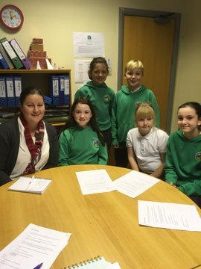
Also some of our Ambassadors met with Caerphilly Catering to discuss ideas for improving the choices of food and having plates instead of trays. Year 5 and 6 are going to be trialing some exciting changes in January!!

Thank you for reading our Newsletter...... watch out for the next update in January! MERRY CHRISTMAS EVERYONE!

Written by Mia Jones and Dawid Urban ( on behalf of all the Ambassadors)

A few pictures from the term… don’t forget to follow us on Twitter @ CwrtRawlinprim
Supporting the Operation Santa Appeal
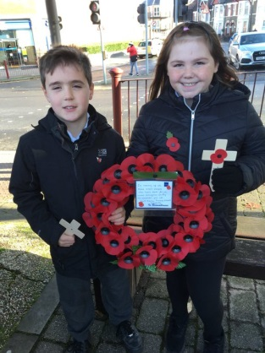
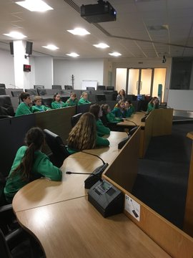
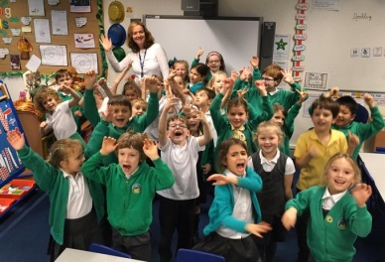
Bye Mrs Blunsdon!
Voting in the Senedd
Remembering Others….

