Sounds and keywords work will be updated weekly on SeeSaw but please see below for C work should you wish to print it off/use as guidance.
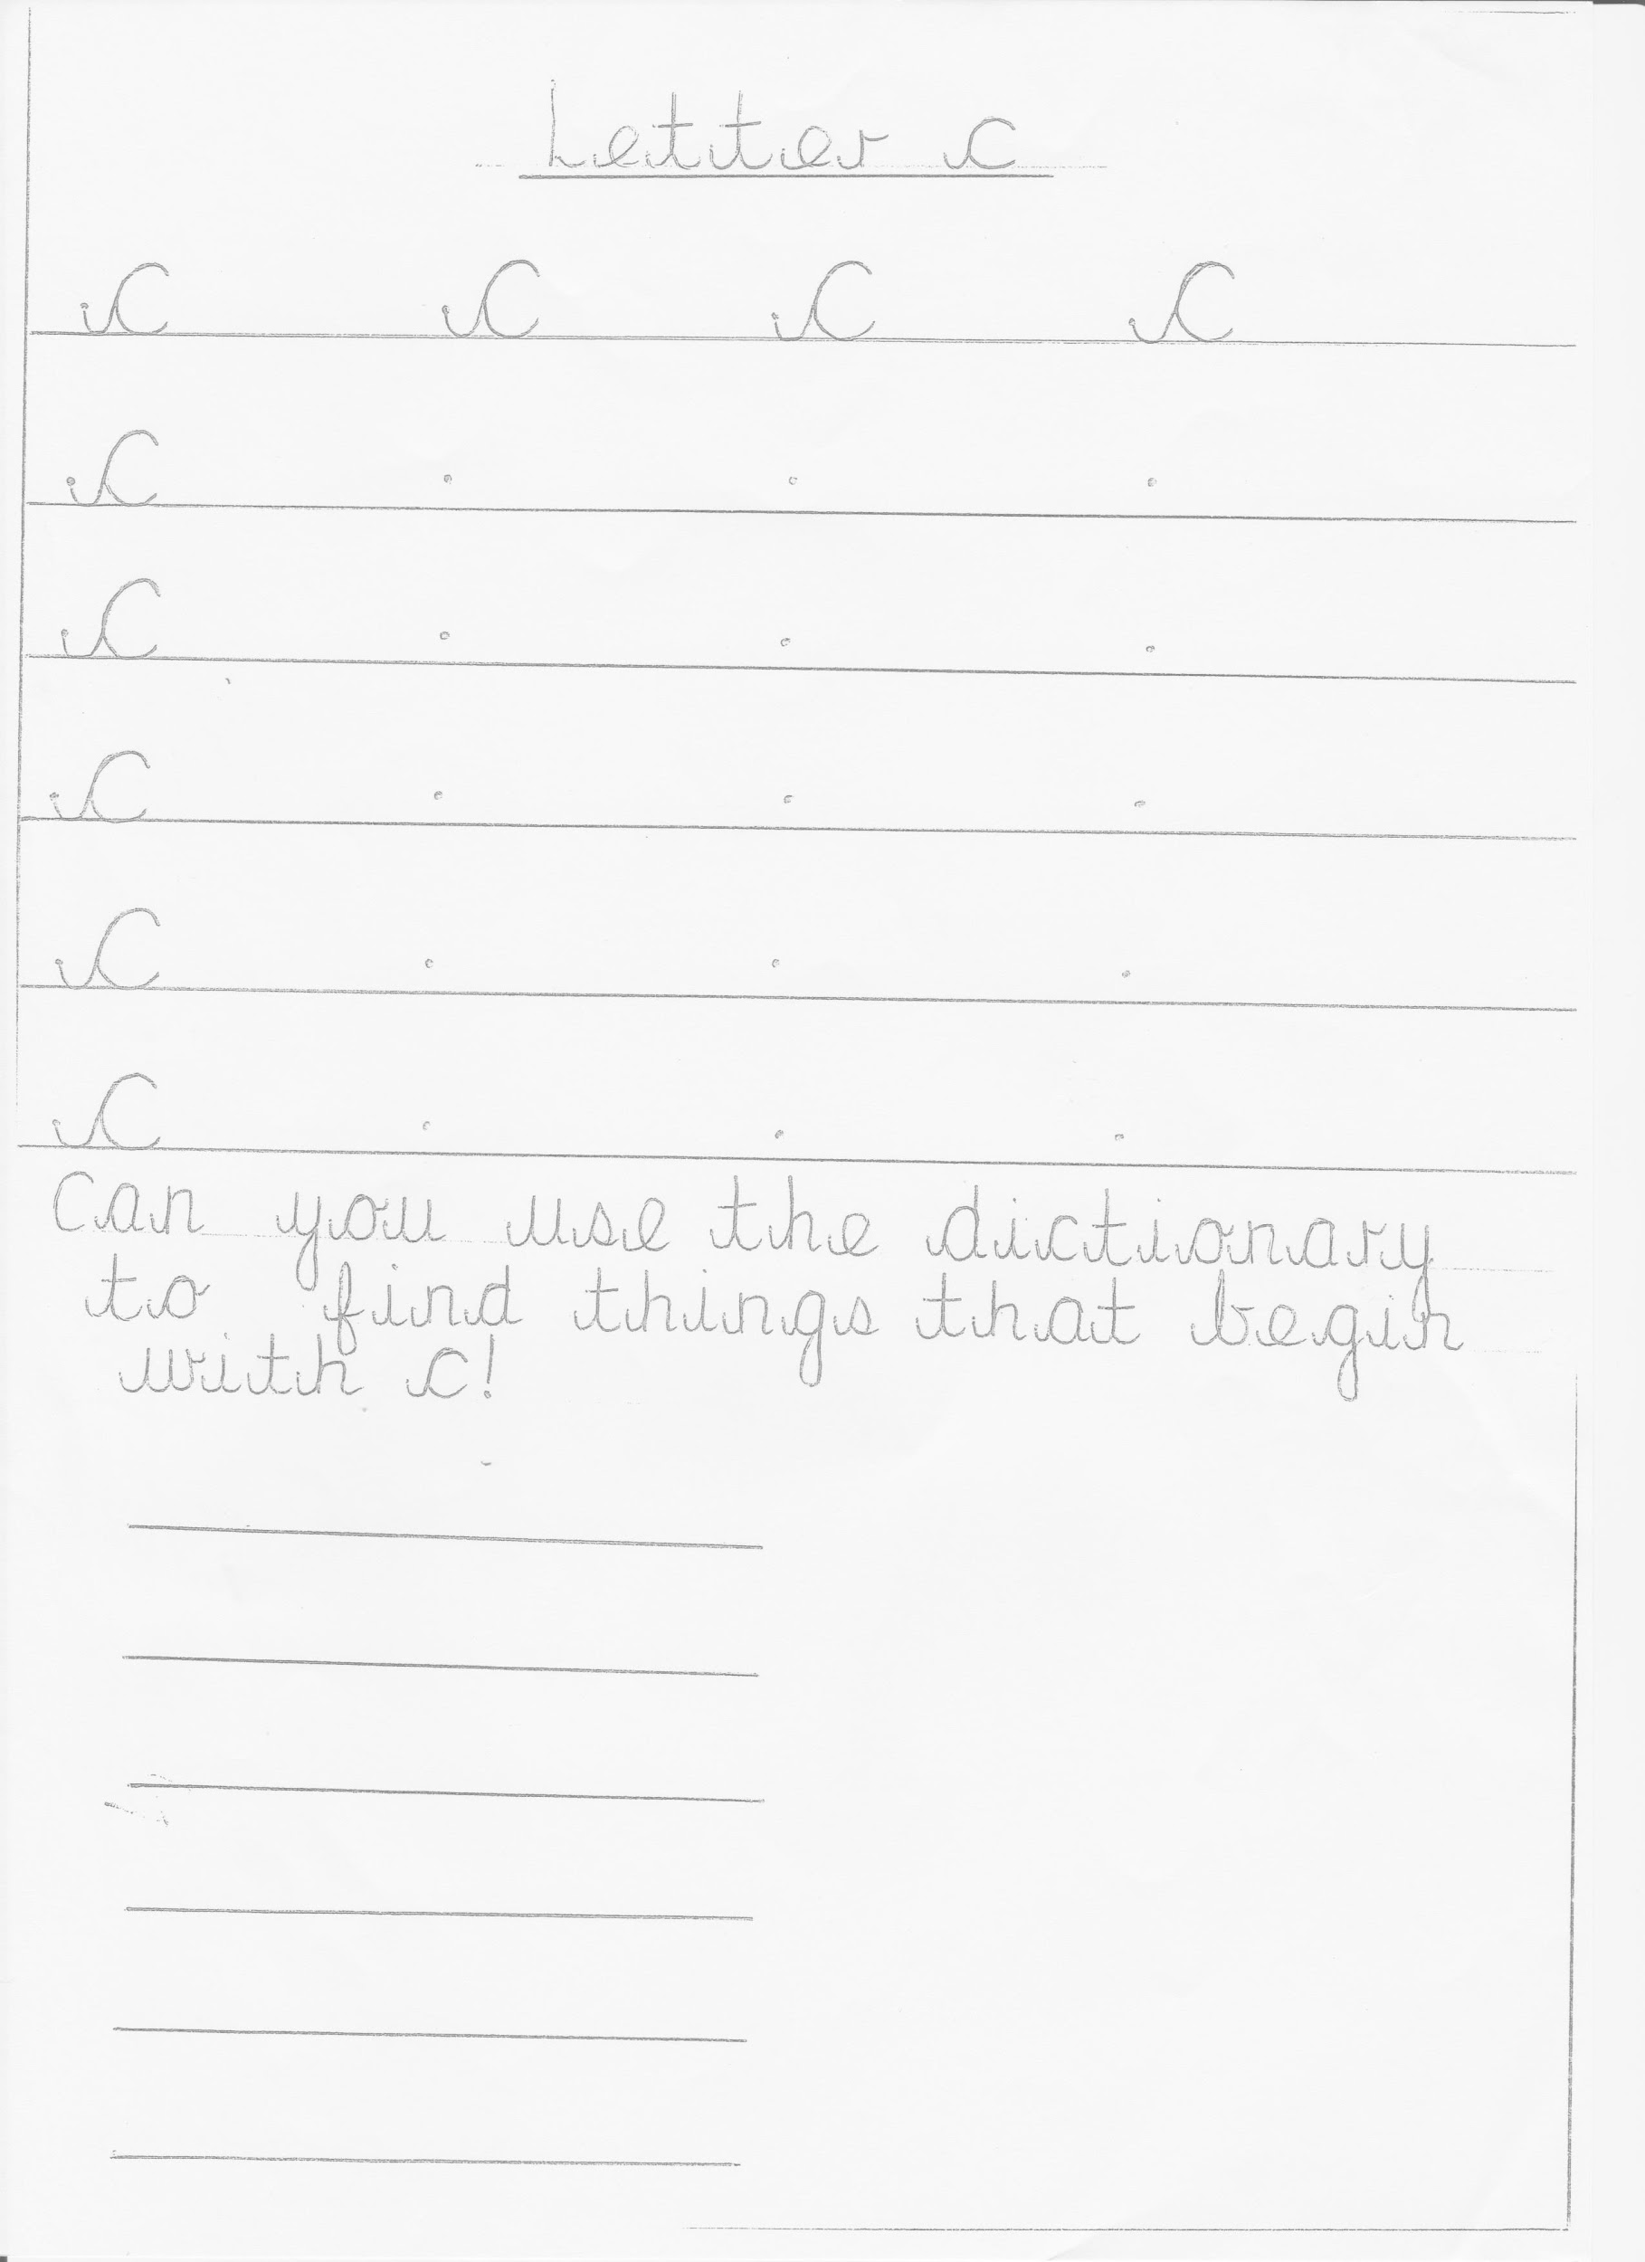
We can’t wait to look at all your amazing work! 😊 Reception Team

