Year 3/4 Homework – 14th November 2019

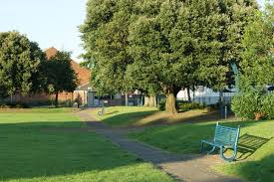

Your homework this week is to write a diary about an event from your weekend. Remember a good diary uses…

Dear Diary and a farewell at the end.

The first person “I”

Past tense – was, saw, went

Events in order

Feelings and emotions – frightened, relieved

Informal language such as I couldn’t believe it…

I look forward to reading them next week.

Year 3/4 Homework – 14th November 2019



Your homework this week is to write a diary about an event from your weekend. Remember a good diary uses…

Dear Diary and a farewell at the end.

The first person “I”

Past tense – was, saw, went

Events in order

Feelings and emotions – frightened, relieved

Informal language such as I couldn’t believe it…

I look forward to reading them next week.