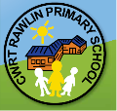
Cwrt Rawlin Primary

Ambassador Newsletter
Football | Football: Both Y6 football teams got through to the New Directions/CCFC final in the Leckwith stadium. Out of many matches we played very well. We had tough opposition in the other teams , but we did our best- they were hard games to win! We enjoyed it very much.
Welsh Workshops  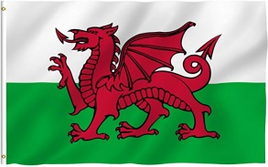 | We enjoyed having all the parents coming in and watching our Welsh lessons and seeing the children’s Welsh improvement. We really enjoyed doing Welsh activities such as reading Welsh books, colouring Welsh flags and talking in Welsh. Da iawn pawb!
School  Lunches  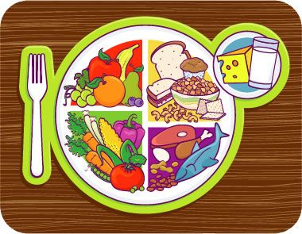  Spain Erasmus Visit | In Year 5 and 6 we have recently been using a band system to order our school dinners. This gives us more choices of what food we can order. We are also using plates and bowls instead of trays. It has been working fantastically! So we are going to roll it out to Year 3 and 4 children. Watch this space…  Mrs Edwards has just come back from a weeks educational trip to Spain. She was learning all about the ways schools work in Spain.. we can’t wait to learn more….. | 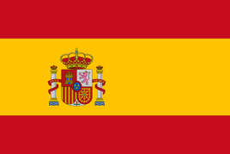
Breaking News......
Our next school, Wellbeing day will be Friday, 14th February, you are invited to wear your own clothes, for a donation of £1 to MindCymru.

The schools St David’s day will be held on Monday, 2nd March, so watch out for all the competitions to enter before and over the half term holiday!
Written by Bella Ashman and Jake Reese (on behalf of all the Ambassadors)

A few pictures from the term… don’t forget to follow us on Twitter @ CwrtRawinprim
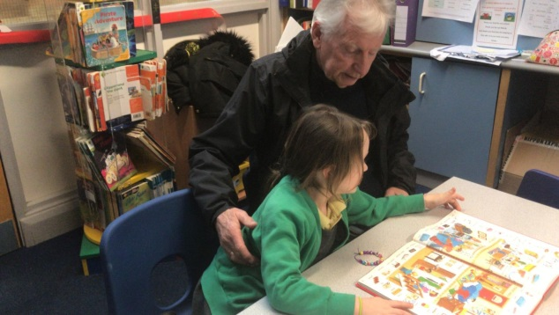
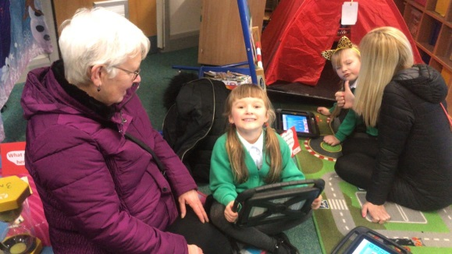
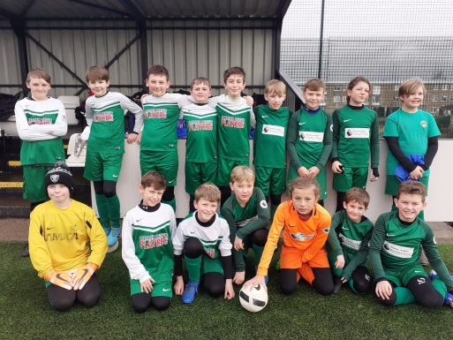
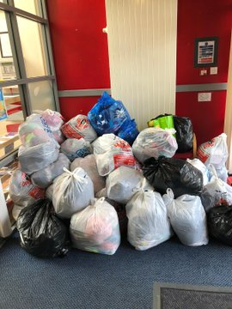
We are a GREEN school!
Thank you for your support for Rags to Riches!
Welsh workshops with our parents, carers and grandparents
Football Finals day

