Week 6 (Wk Commencing 01.06.20)
Text of the Week – The Very Hungry Caterpillar Story link - The story will be read to the children by Mrs Williams (Uploaded on seesaw) they may also like to watch and listen to the story here too; https://www.youtube.com/watch?v=75NQK-Sm1YY
Sound of the week – q
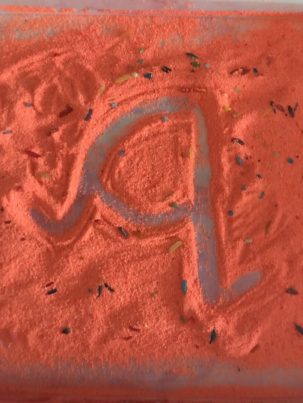
What items can you find around your house that begin with a q? Can you write a q (don’t forget your smile on the line) in the air, on your hand, in shaving foam, using paint, a pencil, or any other lovely ways you can think of.
Language
The children will be learning all about ‘The Very Hungry Caterpillar’ this week. Can you talk about all the things he ate, with your grown up? Which ones do you like/ not like? With your grown up (emphasising the initial sound if needed) can you identify what sound each food item begins with?
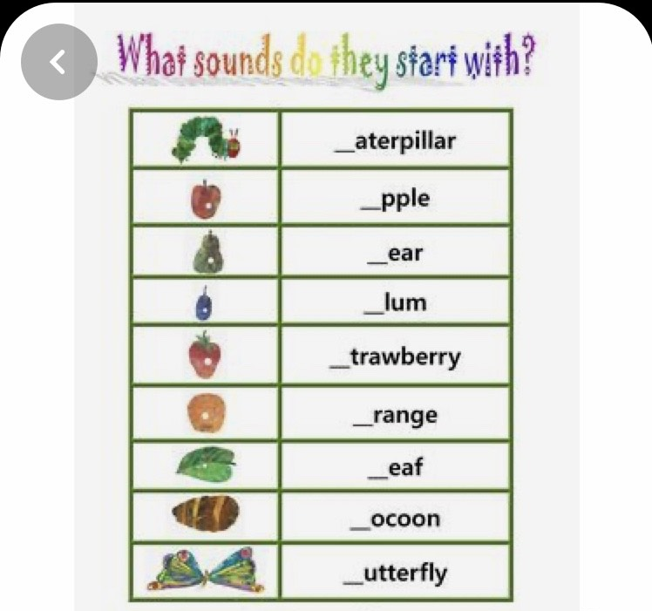
Maths
The Very Hungry Caterpillar gets a little confused with the order of the days of the week. Can you help him to learn the days of the week, in the correct order? You can use this song to help you; https://www.youtube.com/watch?v=mXMofxtDPUQ&vl=en What days do we go to school? What days are we at home?
Can you practise counting backwards; https://www.youtube.com/watch?v=Z1E6JwGYhOY
Science
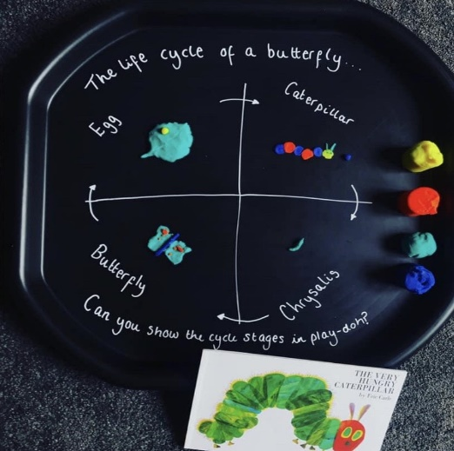
The children will be learning about the life cycle of a butterfly. Can your child recall the life cycle from the story? Can you make the life cycle of a butterfly, using playdoh?

ICT – To use hwb to paint the life cycle of a butterfly https://www.j2e.com/jit5#

Arts and crafts
Can you paint a symmetrical butterfly?
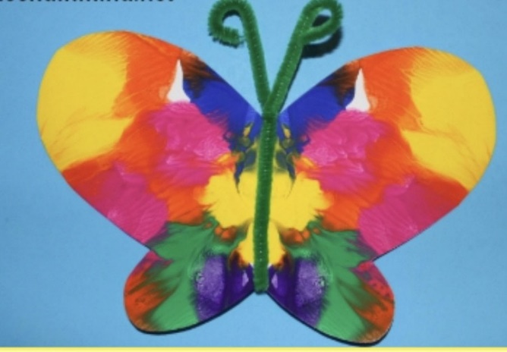
- Fold a piece of paper in half and draw out a butterfly outline, making sure the middle of the butterfly is on the folding line.
2.Paint a simple design onto the wings, on one side only.
3.Fold the paper on the line and tap down on your paint.
4. Now you should have a beautiful symmetrical butterfly!

Outdoor walk
On your daily walk, can you collect a large, strong, leaf? Can your grown up make some holes around the edge of the leaf, for you to thread some string through? Helping to develop those fine motor skills.
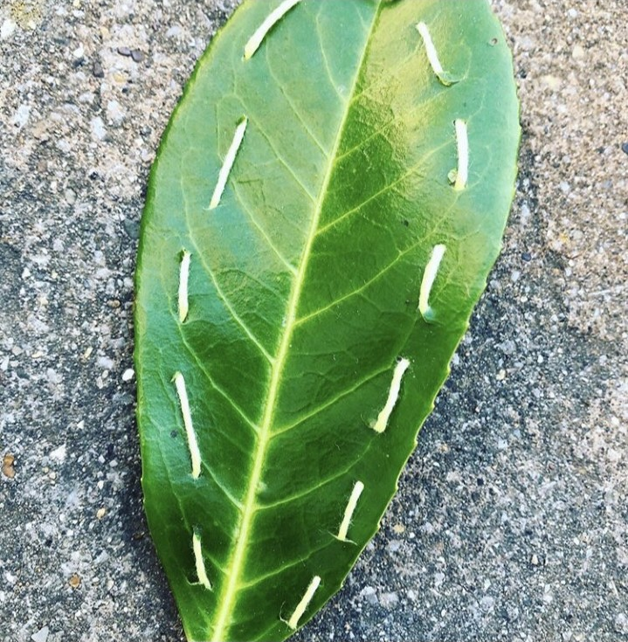

PSWBCD
Can you talk to your children about healthy and unhealthy foods. Which food items that the hungry caterpillar ate, are healthy and which are unhealthy? Can you help your grown up to make a healthy snack for you, using some of your favourite snack foods?
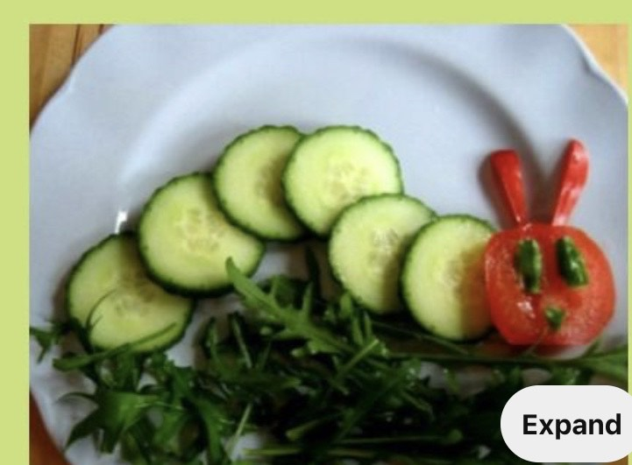

Ongoing activities
- Practise writing their name
- Can children talk about the sounds at the start of words? Recap on the letter sounds we have covered so far i, t, u, j, y, r, n, m, p, c, a, d, g, o
- https://www.youtube.com/watch?v=eTEmtADqMFg
- Lots of counting activities, what is 1 more/1 less than a number
- Practise forming numbers 0-5. Move on to 5-10 when ready.
- Encourage your child to put on their own coats and zip them up independently
- Take part in lots of physical activities; playing outside, scooting, skipping, running etc
- Take turns in a family game and play independently
- Practise the welsh phrases/songs we have covered so far:
- Boreda/Prynhawn da (Good morning/afternoon)
- Pwy wyt ti? (Who are you?)
- Sut wyt ti? (How are you?)
- Sut mae’r tywydd heddiw? (What is the weather like?)
- Sawl? (How many?)
- Pa liw? (What colour?)
- Coch- red, melyn – yellow, glas – blue, oren – orange, gwyrdd – green.

ICT links;
https://www.topmarks.co.uk/maths-games/3-5-years/ordering-and-sequencing
https://www.phonicsplay.co.uk/Phase1Menu.htm
https://www.topmarks.co.uk/english-games/3-5-years/letters-and-sounds
https://www.learninggamesforkids.com/preschool-games.html
https://www.bbc.co.uk/cbeebies/games/age-and-needs/pre-school

We hope that you had a lovely half term in the glorious sunshine and that this finds you all safe and well! We hope you enjoy the activities above, but please feel free to adapt them and come up with your own ideas, based on the ideas we have given you. Use any resources you have around the house to practise the skill focus, under the subjects above.

Many thanks,
Mrs Williams, Mrs Edwards and team.

What is your Giant called? ___________________

