Week 8 (Wk Commencing 15.06.20)
Text of the Week – Superworm by Julia Donaldson
Story link - The story will be read to the children, by Mrs Williams (Uploaded on seesaw) they may also like to watch and listen to the story here too; https://www.youtube.com/watch?v=7Jnk3XApKBg
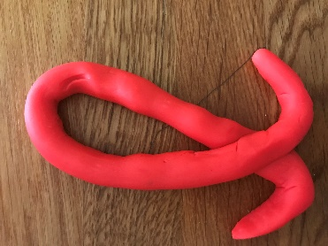
Sound of the week – l
What items can you find around your house that begin with an l? Can you write an l using our special handwriting style? Can you write it in the air, on your Mum/ Dads back? or any other lovely ways you can think of.
Language
The children will be listening to the story of the Superworm this week. Can you talk about all the lovely bugs that Superworm came across in the story, with your grown up?
When you have listened to the story (by Mrs Williams and maybe your grown up or via the link above) Do you think you could retell parts of the story in your own words and using the pictures to help you? We would love you to share these short videos on seesaw too
Maths
Superworm is super long! How long do you think he is? Could you make a long worm, representing how long you think he might be, using string, blocks, cars etc. We looked at patterns, measured ourselves next to our worm and counted the amount of blocks we used too.
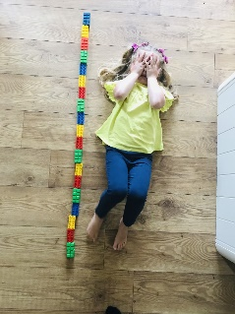
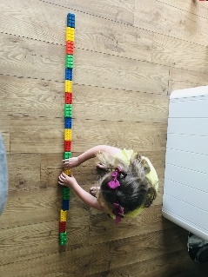

Can you practise counting backwards from 10; https://www.youtube.com/watch?v=Z1E6JwGYhOY
Science – Learn all about worms in this short, child friendly video and discuss with your grown up after; https://www.youtube.com/watch?v=kWb6HlBhkfQ
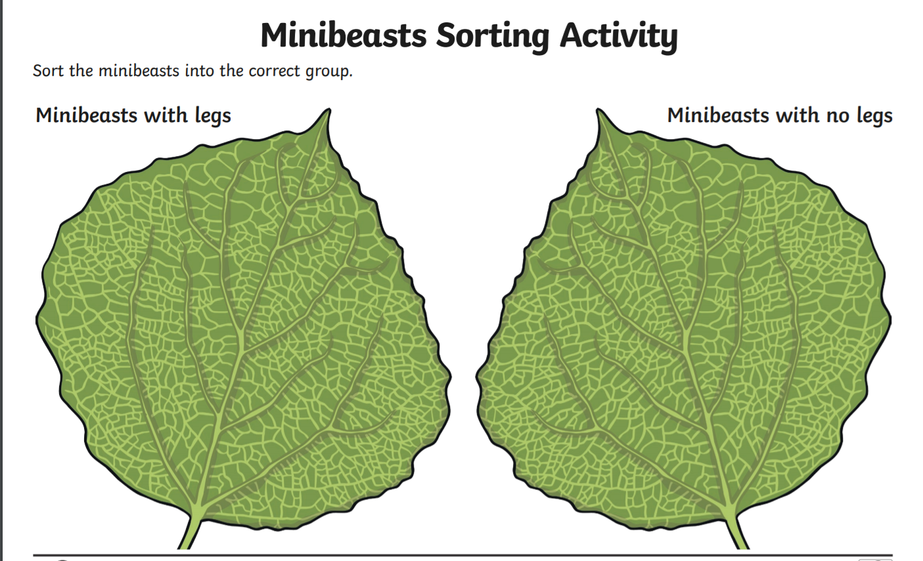
Can you sort these bugs into groups, allow your child the chance to sort the bugs by their own ideas, could be fly/ can’t fly, underground/ over ground. You do not have to use the example below, if they have great ideas of their own!
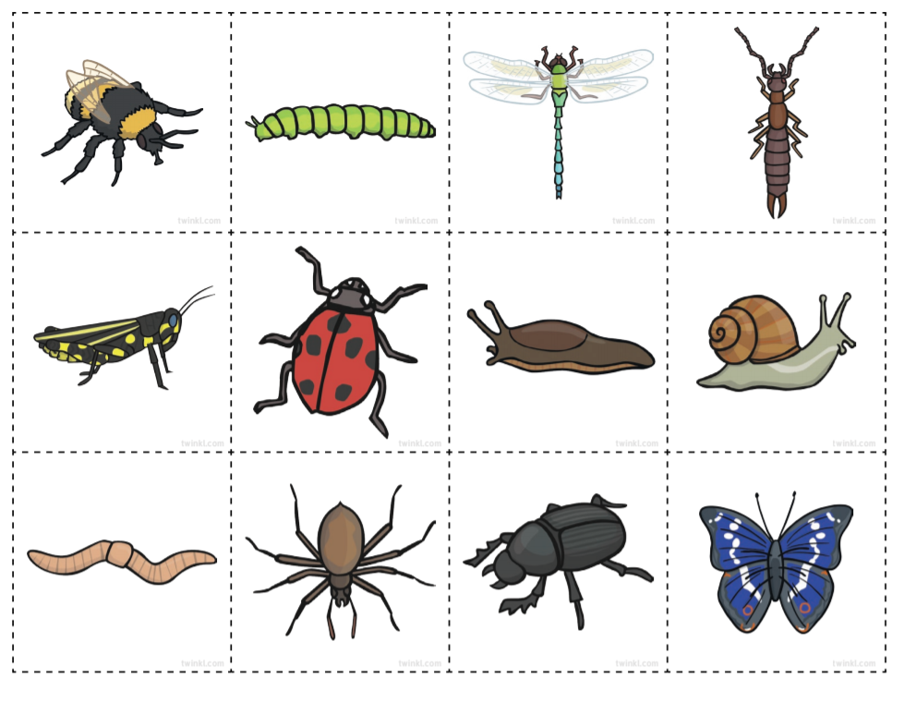

ICT – To use hwb to create a picture of Superworm, or another bug from the story. https://www.j2e.com/jit5#
Music - Learn all about minibeasts through this lovely song. https://www.youtube.com/watch?v=LoIeeIEPGJI Can you watch it again and try and sing along too?
PSWBCD
With the weather not looking too good at the moment I have sent a lovely link for some well being activities for you to do with your children, when you are stuck indoors. https://www.5minutefun.com/wellbeing-activities-for-kids-stuck-indoors/
PE
Stick insect yoga -https://www.youtube.com/watch?v=wBdMZMEKq-s
Minibeast dance - https://www.youtube.com/watch?v=hUbYq93cYdE

Ongoing activities
- Practise writing their name
- Can children talk about the sounds at the start of words? Recap on the letter sounds we have covered so far i, t, u, j, y, r, n, m, p, c, a, d, g, o, q, a
- https://www.youtube.com/watch?v=eTEmtADqMFg
- Lots of counting activities, what is 1 more/1 less than a number
- Practise forming numbers 0-5. Move on to 5-10 when ready.
- Encourage your child to put on their own coats and zip them up independently
- Take part in lots of physical activities; playing outside, scooting, skipping, running etc
- Take turns in a family game and play independently
- Practise the welsh phrases/songs we have covered so far:
- Boreda/Prynhawn da (Good morning/afternoon)
- Pwy wyt ti? (Who are you?)
- Sut wyt ti? (How are you?)
- Sut mae’r tywydd heddiw? (What is the weather like?)
- Sawl? (How many?)
- Pa liw? (What colour?)
- Coch- red, melyn – yellow, glas – blue, oren – orange, gwyrdd – green.

ICT links;
https://www.topmarks.co.uk/maths-games/3-5-years/ordering-and-sequencing
https://www.phonicsplay.co.uk/Phase1Menu.htm
https://www.topmarks.co.uk/english-games/3-5-years/letters-and-sounds
https://www.learninggamesforkids.com/preschool-games.html
https://www.bbc.co.uk/cbeebies/games/age-and-needs/pre-school

We hope you enjoy the activities above, but please feel free to adapt them and come up with your own ideas, based on the ideas we have given you. Use any resources you have around the house to practise the skill focus, under the subjects above.

Many thanks
Mrs Edwards, Mrs Williams and team.

What is your Giant called? ___________________

