Week 10 (Wk Commencing 29.06.20)
Text of the Week – The Snail Trail
The story will be read to the children, by Mrs Williams (Uploaded on seesaw)
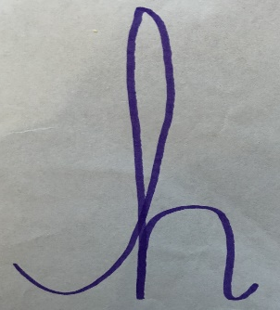
Sound of the week – h
What items can you find on your daily walks or around your house that begin with a h? Can you write a h using our special handwriting style? Can you write it in the air, on your hand, in shaving foam? or any other lovely ways you can think of.

Language
The snail travelled on a lovely adventure, to find a place to sleep. Do you think you or your favourite toy could go on your own adventure and travel through, under and over some things? You can take some photos of your journeys being acted out, or draw a map and we would love to see them on seesaw.
Encourage your child to use everyday words to describe position and direction.
Directional and positional vocabulary: up, down, across, over, under, around, through, on top, inside, beside, between, underneath.
Extension; Play directional games, for example, 'Simon says' and 'Follow my leader'
Maths - Snail race
1. Can you go on a snail hunt and find three (or more) snails in your garden?
2. Draw out some lanes on a large piece of paper, ask your child to number the lanes to practise their number formation.
3. When they have done this, put a snail in each lane with some cucumber on the finishing line and ask them which snail they think will win the race and why? This will develop their estimation and thinking skills. Why do they think that snail will win? Encourage them to give explanations for their answers.
4. While the snails are moving, how are they moving? Fast/ slow, in a straight/ curved line? Can you see how the snail has moved? (observe the snail trail) What does he leave behind to show his route?
5. When the snails finally reach the finishing line, can your child tell you which snail came 1st, 2nd, 3rd, 4th etc, encouraging them to use this language.

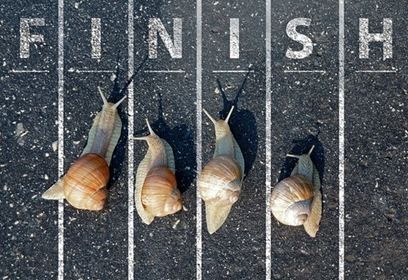

Art
Can you create a snail collage, using coloured pieces of paper? Encourage your child to arrange the paper to make a spiral, just like the snails shell. I can’t wait to see your masterpieces!
Below is a famous collage of a snail, by Henry Matisse. This piece of art can be seen in the London art gallery.
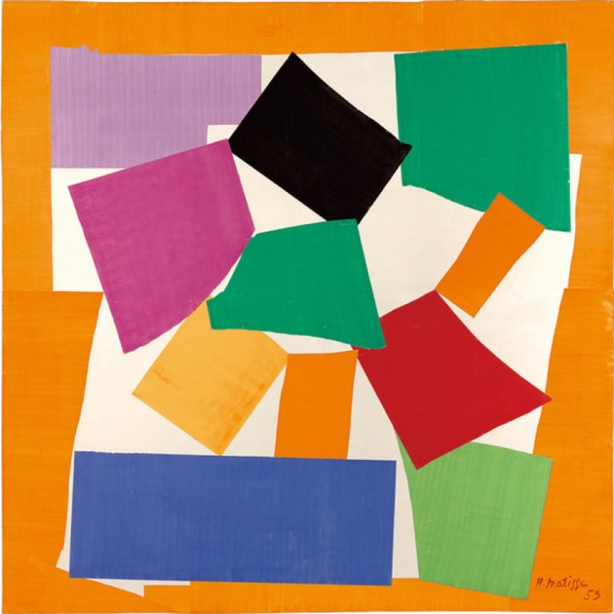

Science
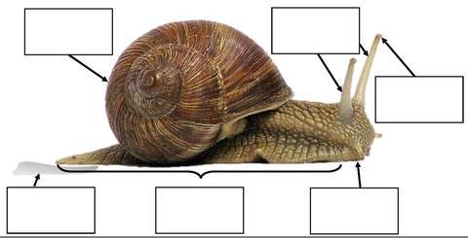
Can you label the parts of the snail?

PSWBCD
Well-being story and poster all about returning to school, for those little ones who are a little worried after being off for so long;
file:///C:/Users/Luke%20Williams/Downloads/sammy-sloth-story-edited-version-A4%20(1).pdf

ICT – To use hwb to create a picture of a snail and write about his body parts https://www.j2e.com/jit5#
Music -Learn all about minibeasts through this lovely song. https://www.youtube.com/watch?v=LoIeeIEPGJI Can you watch it again and try and sing along too?

PE
Cosmic Yoga, All about bugs - https://www.youtube.com/watch?v=qIT-9Nnlvn0
Minibeast dance - https://www.youtube.com/watch?v=hUbYq93cYdE

Ongoing activities
- Practise writing their name
- Can children talk about the sounds at the start of words? Recap on the letter sounds we have covered so far i, t, u, j, y, r, n, m, p, c, a, d, g, o, q, a, l and b
- https://www.youtube.com/watch?v=eTEmtADqMFg
- Lots of counting activities, what is 1 more/1 less than a number
- Practise forming numbers 0-5. Move on to 5-10 when ready.
- Encourage your child to put on their own coats and zip them up independently
- Take part in lots of physical activities; playing outside, scooting, skipping, running etc
- Take turns in a family game and play independently
- Practise the welsh phrases/songs we have covered so far:
- Boreda/Prynhawn da (Good morning/afternoon)
- Pwy wyt ti? (Who are you?)
- Sut wyt ti? (How are you?)
- Sut mae’r tywydd heddiw? (What is the weather like?)
- Sawl? (How many?)
- Pa liw? (What colour?)
- Coch- red, melyn – yellow, glas – blue, oren – orange, gwyrdd – green.

ICT links;
https://www.topmarks.co.uk/maths-games/3-5-years/ordering-and-sequencing
https://www.phonicsplay.co.uk/Phase1Menu.htm
https://www.topmarks.co.uk/english-games/3-5-years/letters-and-sounds
https://www.learninggamesforkids.com/preschool-games.html
https://www.bbc.co.uk/cbeebies/games/age-and-needs/pre-school

We hope you enjoy the activities above, but please feel free to adapt them and come up with your own ideas, based on the ideas we have given you. Use any resources you have around the house to practise the skill focus, under the subjects above. We would love to see what you have been doing at home! Please could you all try your best, to upload at least one piece of work for us to see.

Many thanks
Mrs Edwards, Mrs Williams and team.

What is your Giant called? ___________________

