**Week 5** (Wk Commencing 18.05.20)

**Text of the week:** The Little Red Hen

**Sound of the week**: O

What can you find around your house that begins with an O?

How many different ways can your child practise o? e.g. playdough, shaving foam, chalk, sand etc. May be you could find circular objects around the house and have a go at printing with them.

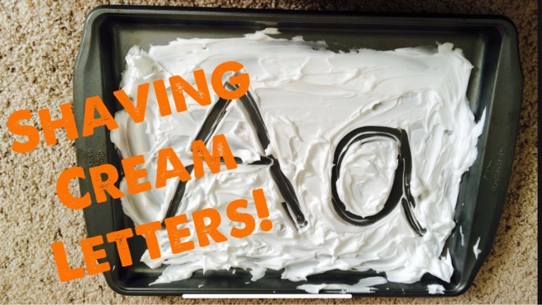

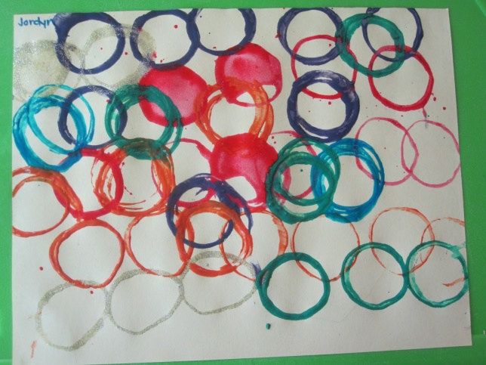

Language

This week our text will be ‘The Little Red Hen’. You will be sent a video of the story being read by Mrs Edwards on Monday morning (Seesaw). You can also access the story at the link below:

<https://www.youtube.com/watch?v=yclc22I4Zxk>

Listen to the story, can the children join in with the parts spoken by the cat, rat and pig? What do the children think of the story? Can they guess what might happen at the end when the little red hen has made the bread? Do they think the little red hen was right not to share her bread with cat, rat and pig?

We would like the children to sequence the bread making process. Can they draw pictures of each part?

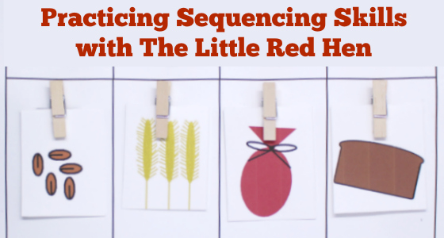



Yum yum!



Maths

Place A4 pieces of paper with numbers on a surface e.g. table, floor, lawn. Can children find different items for each number e.g. 2 pieces of lego, 4 items that are red, 7 sticks, 10 leaves etc. You can also turn the numbers over and reveal one at a time, can you child recognise the number and do that many jumps/hops/star jumps etc

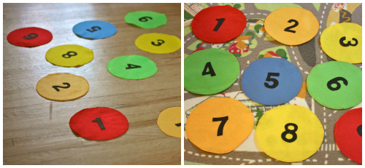

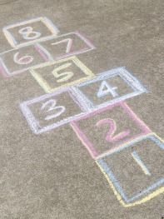Play a game of hopscotch. Roll a dice and jump to that number. If you don’t have a set, you can draw the numbers on the floor with chalk.

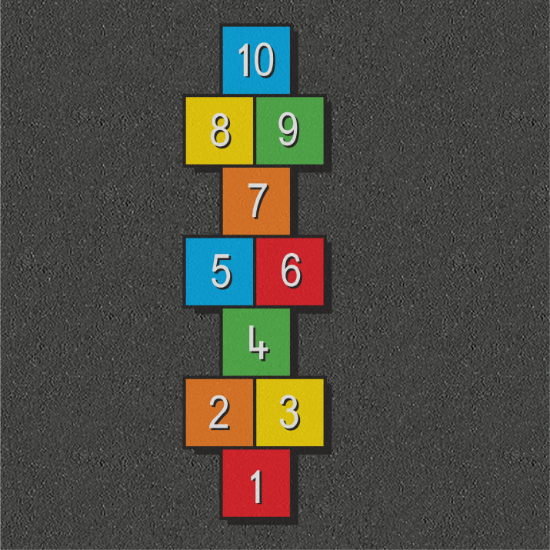

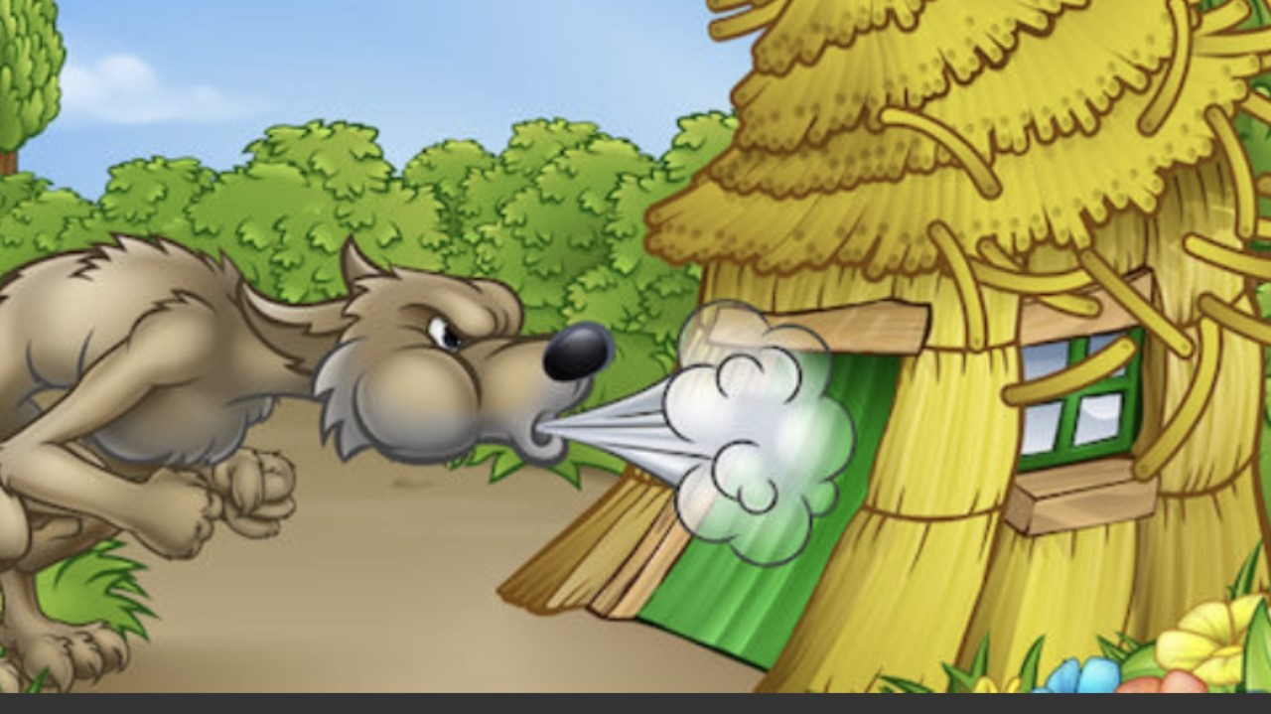**Science**

Can you make a loaf of bread? Here is a simple recipe if you have/can get the ingredients:

Easy white bread

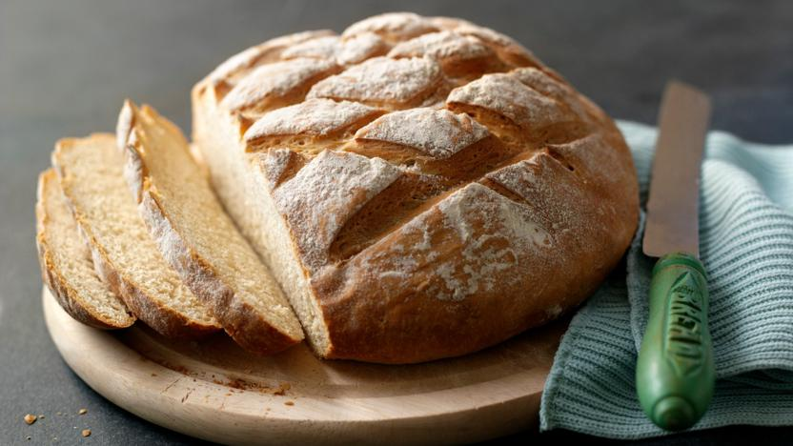

Ingredients

* 500g/1lb 1oz strong white bread flour, plus a little extra flour for finishing
* 40g/1½oz soft [butter](https://www.bbc.co.uk/food/butter)
* 7g sachet fast-action dried [yeast](https://www.bbc.co.uk/food/yeast)
* 1½ tsp [salt](https://www.bbc.co.uk/food/salt)
* about 300ml/10¾fl oz tepid water (warm not cold – about body temperature)
* a little olive or [sunflower oil](https://www.bbc.co.uk/food/sunflower_oil)

Method

1. Put the flour into a large mixing bowl and add the butter. Add the yeast at one side of the bowl and add the salt at the other, otherwise the salt will kill the yeast. Stir all the ingredients with a spoon to combine.
2. Add half of the water and turn the mixture round with your fingers. Continue to add water a little at a time, combining well, until you’ve picked up all of the flour from the sides of the bowl. You may not need to add all of the water, or you may need to add a little more – you want a dough that is well combined and soft, but not sticky or soggy. Mix with your fingers to make sure all of the ingredients are combined and use the mixture to clean the inside of the bowl. Keep going until the mixture forms a rough dough.
3. Use about a teaspoon of oil to lightly grease a clean work surface (using oil instead of flour will keep the texture of the dough consistent). Turn out your dough onto the greased work surface (make sure you have plenty of space).
4. Fold the far edge of the dough into the middle of the dough, then turn the dough by 45 degrees and repeat. Do this several times until the dough is very lightly coated all over in olive oil.
5. Now use your hands to knead the dough: push the dough out in one direction with the heel of your hand, then fold it back on itself. Turn the dough by 90 degrees and repeat. Kneading in this way stretches the gluten and makes the dough elastic. Do this for about 4 or 5 minutes until the dough is smooth and stretchy. Work quickly so that the mixture doesn’t stick to your hands – if it does get too sticky you can add a little flour to your hands.
6. Clean and lightly oil your mixing bowl and put the dough back into it. Cover with a damp tea towel or lightly oiled cling film and set it aside to prove. This gives the yeast time to work: the dough should double in size. This should take around one hour, but will vary depending on the temperature of your room (don’t put the bowl in a hot place or the yeast will work too quickly).
7. Line a baking tray with baking or silicone paper (not greaseproof).
8. Once the dough has doubled in size scrape it out of the bowl to shape it. The texture should be bouncy and shiny. Turn it out onto a lightly floured surface and knock it back by kneading it firmly to 'knock' out the air. Use your hand to roll the dough up, then turn by 45 degrees and roll it up again. Repeat several times. Gently turn and smooth the dough into a round loaf shape.
9. Place the loaf onto the lined baking tray, cover with a tea towel or lightly oiled cling film and leave to prove until it’s doubled in size. This will take about an hour, but may be quicker or slower depending on how warm your kitchen is.
10. Preheat the oven to 220C (200C fan assisted)/425F/Gas 7. Put an old, empty roasting tin into the bottom of the oven.
11. After an hour the loaf should have proved (risen again). Sprinkle some flour on top and very gently rub it in. Use a large, sharp knife to make shallow cuts (about 1cm/½in deep) across the top of the loaf to create a diamond pattern.
12. Put the loaf (on its baking tray) into the middle of the oven. Pour a little water into the empty roasting tray at the bottom of the oven just before you shut the door – this creates steam which helps the loaf develop a crisp and shiny crust.
13. Bake the loaf for about 30 minutes.
14. The loaf is cooked when it’s risen and golden. To check, take it out of the oven and tap it gently underneath – it should sound hollow. Turn onto a wire rack to cool.

Arts and Crafts

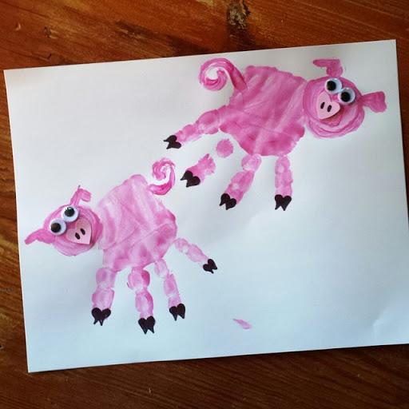Can you use your handprint to create one of the characters?

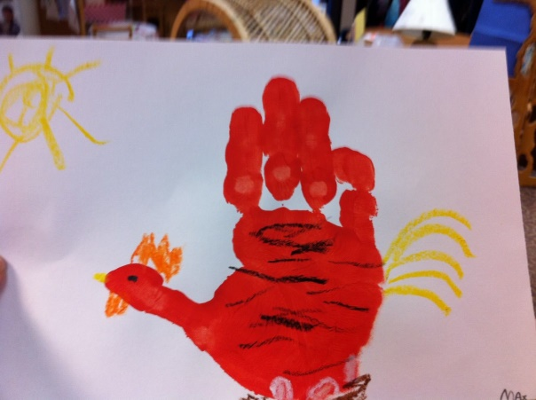

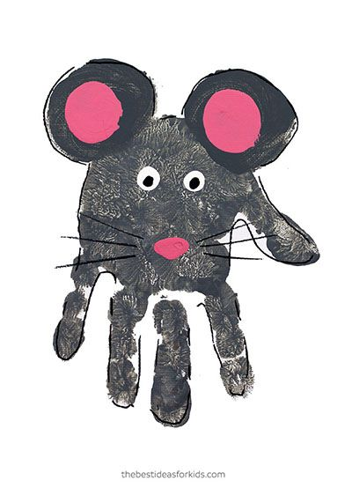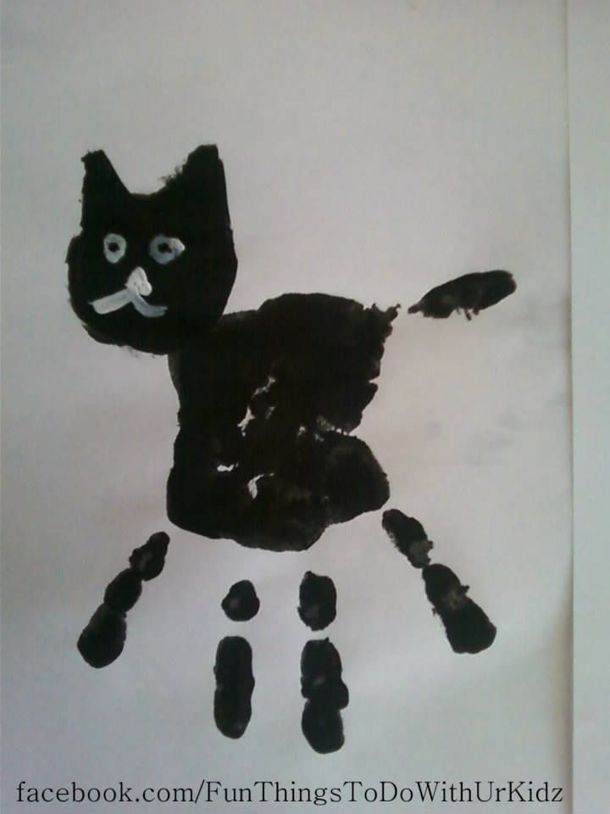

**Outdoors**

Can use mud, leaves and mix them in a saucepan to pretend you’re making bread?

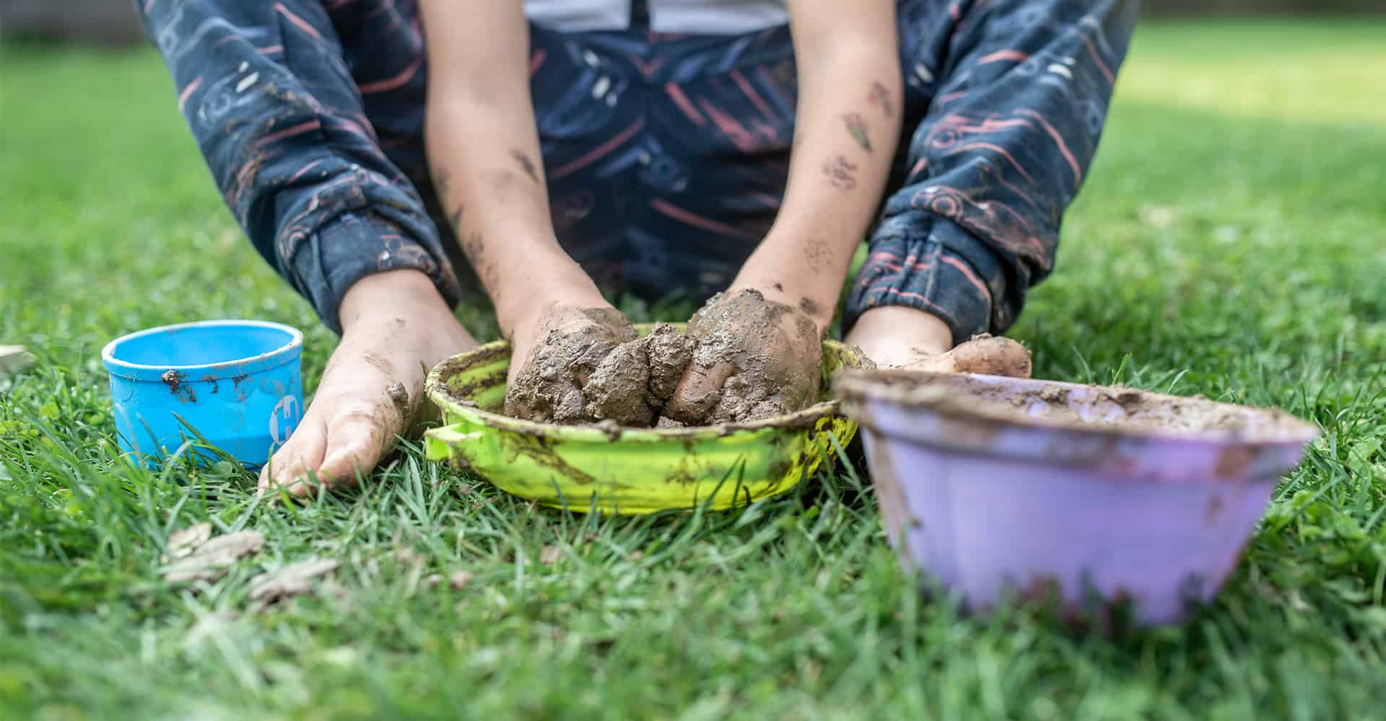

**PE**

you challenge yourself and see how many different exercises you could do in 1 minute e.g. trampolining, star jumps, shuttle runs, passing/kicking a ball etc. Remember to keep practising our key skills of skipping, hopping and jumping on 2 feet.

**PSWBCD**

I thought this was a lovely idea to complete with your child. You just ask them 3 questions and write down their ideas/thoughts for when all this is over: You can keep the ideas in a jar and keep adding to it.

* 1. What 3 things do you miss doing?
  2. What 3 things can you not wait for us to do again?
  3. What 3 new things shall we try when all this is over?

**Ongoing activities**

* Practise writing their name
* Can children talk about the sounds at the start of the word? Recap on the letter sounds we have covered so far i, t, u, j, y, r, n, m, p, c, a,
* Lots of counting activities, what is 1 more/1 less than a number
* Practise forming numbers 0-10
* Encourage your child to put on their own coats and zip them up independently
* Take part in lots of physical activities; playing outside, scooting, skipping, running etc
* Take turns in a family game and play independently
* Practise the welsh phrases/songs we have covered so far:
* Boreda/Prynhawn da (Good morning/afternoon)
* Pwy wyt ti? (Who are you?)
* Sut wyt ti? (How are you?)
* Sut mae’r tywydd heddiw? (What is the weather like?)
* Sawl? (How many?)
* Pa liw? (What colour?)
* Coch- red, melyn – yellow, glas – blue, oren – orange, gwyrdd – green.

**ICT links;**

<https://www.topmarks.co.uk/maths-games/3-5-years/ordering-and-sequencing>

<https://www.phonicsplay.co.uk/Phase1Menu.htm>

<https://www.topmarks.co.uk/english-games/3-5-years/letters-and-sounds>

<https://www.learninggamesforkids.com/preschool-games.html>

<https://www.bbc.co.uk/cbeebies/games/age-and-needs/pre-school>

We hope you are all safe and well and staying positive. We would just like to say a massive thank you for supporting your child’s learning through these difficult times. We have been blown away by your efforts and love seeing everything you have done on Seesaw. It is really hard to juggle everything at the moment, especially if you are still working, so if you don’t have time to do any of the above activities, please don’t worry. You and your child’s wellbeing is the most important focus at the moment.

We are here to help and support you at this difficult time, so please get in touch if we can help.

Many thanks,

Mrs Edwards, Mrs Williams and the Nursery team.

What is your Giant called? ___________________