**Week 7** (Wk Commencing 8.06.20)

**Text of the week:** Mad About Minibeasts by Giles Andreae

**Sound of the week**: e

What can you find around your house that begins with an e?

How many different items can you find around the haouse that begin with e? Can you draw them and have a go at labelling them with help from a parent, big broother/sister?

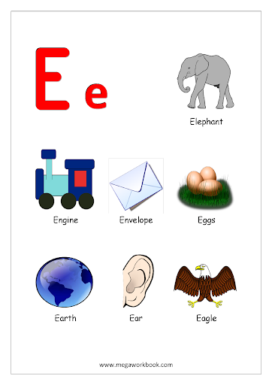

Language

This week our text will be ‘Mad About Minibeasts!’. You will be sent a video of the story being read by Mrs Edwards on Monday morning (Seesaw). You can also access the poems at the link below:

<https://www.youtube.com/watch?v=AKx59b5yv1s>

Listen to the poems, can your child guess which minibeast is being described by listening to the poem without looking at the pictures? Talk about how this book is different from a story book, can they spot any rhyming words?

Can children choose the correct rhyming words from the options below?

Bug

1. cat
2. rug
3. rabbit
4. jug

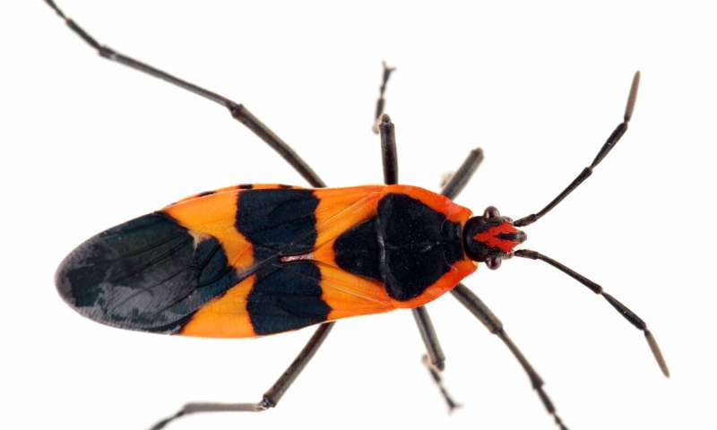

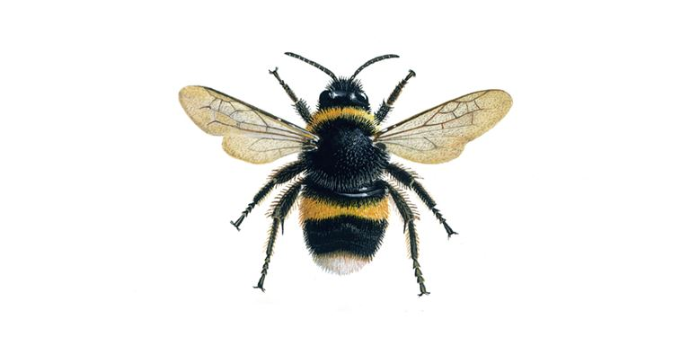Bee

1. food
2. leaf
3. tree
4. key

Ant

1. plant
2. bird
3. insect
4. rant

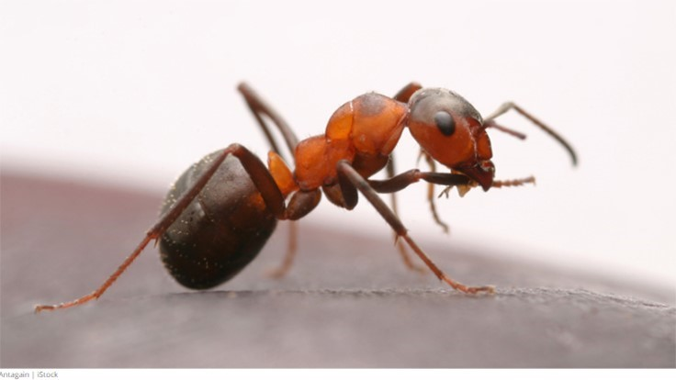

Fly

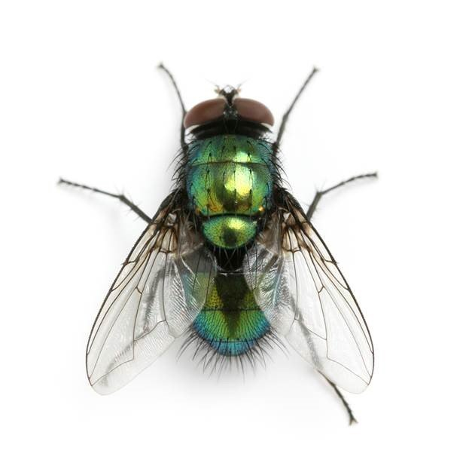

1. apple
2. bye
3. mug
4. my

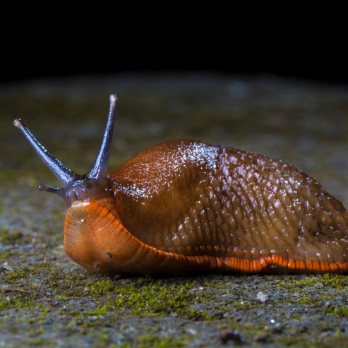Slug

1. plug
2. rug
3. glass
4. stick

Maths/Science

**Bug hunt**

**Can you find these bugs and insects? Write how many you found of each in the boxes below.**

**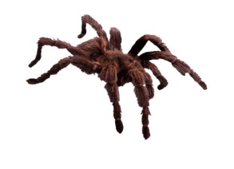Spider MCBD07377_0000[1] Worm**

**MCj03469390000[1]Centipede MCj03468950000[1]Beetle**

**MCj03469250000[1]Ladybird MCAN01186_0000[1] Snail**

**MCAN01211_0000[1] Ant MCj03469530000[1] Caterpillar**

**Draw what else you found.**

Arts and Crafts

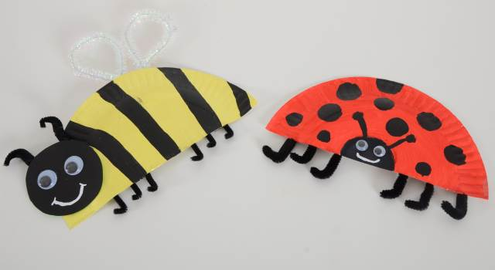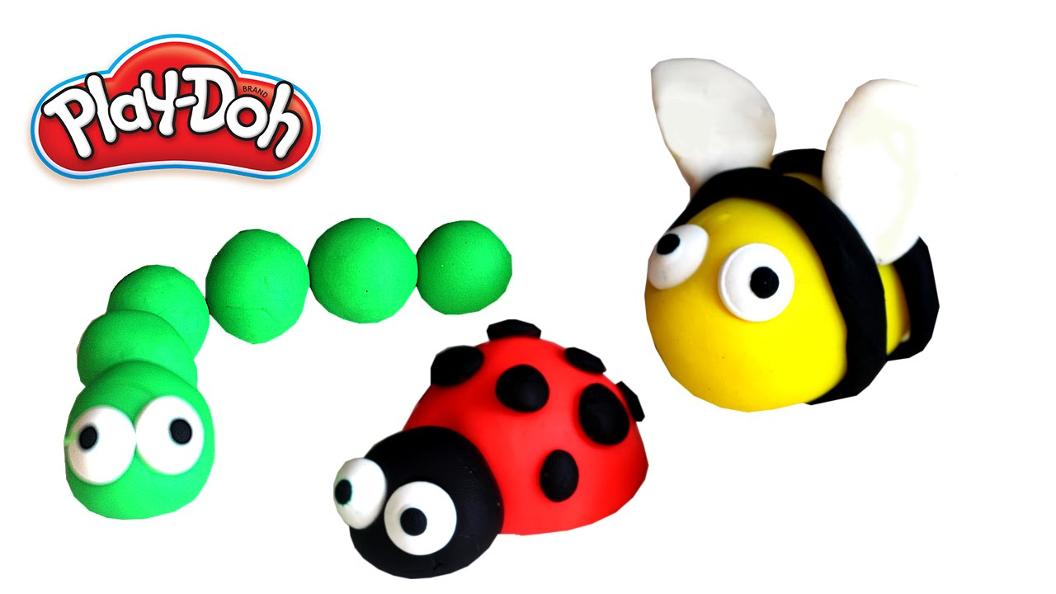Can you choose a minibeast out of the book which you can re-create? Here are a few ideas for you:

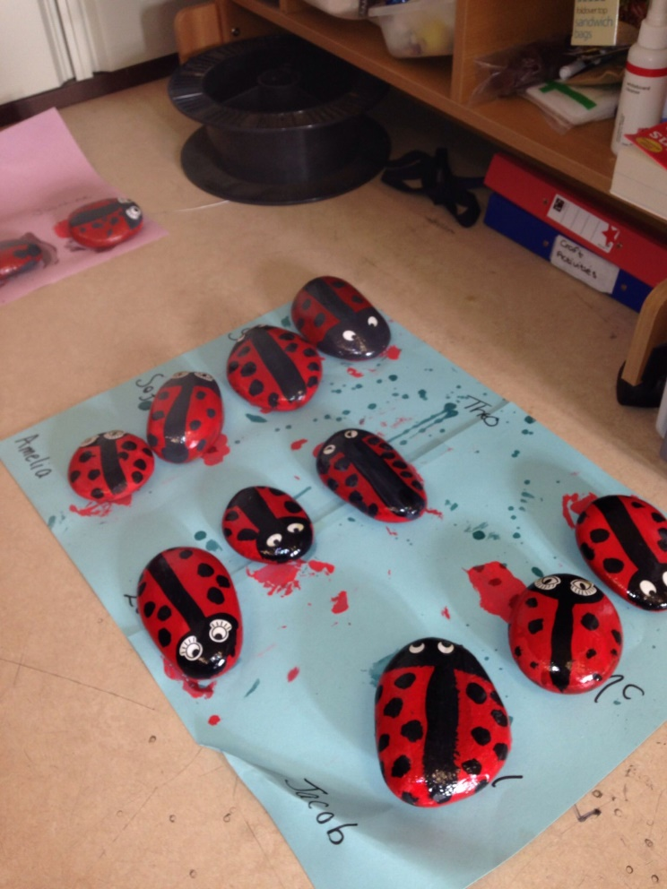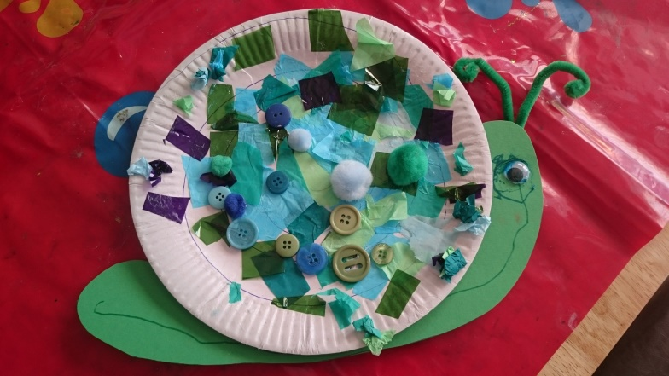

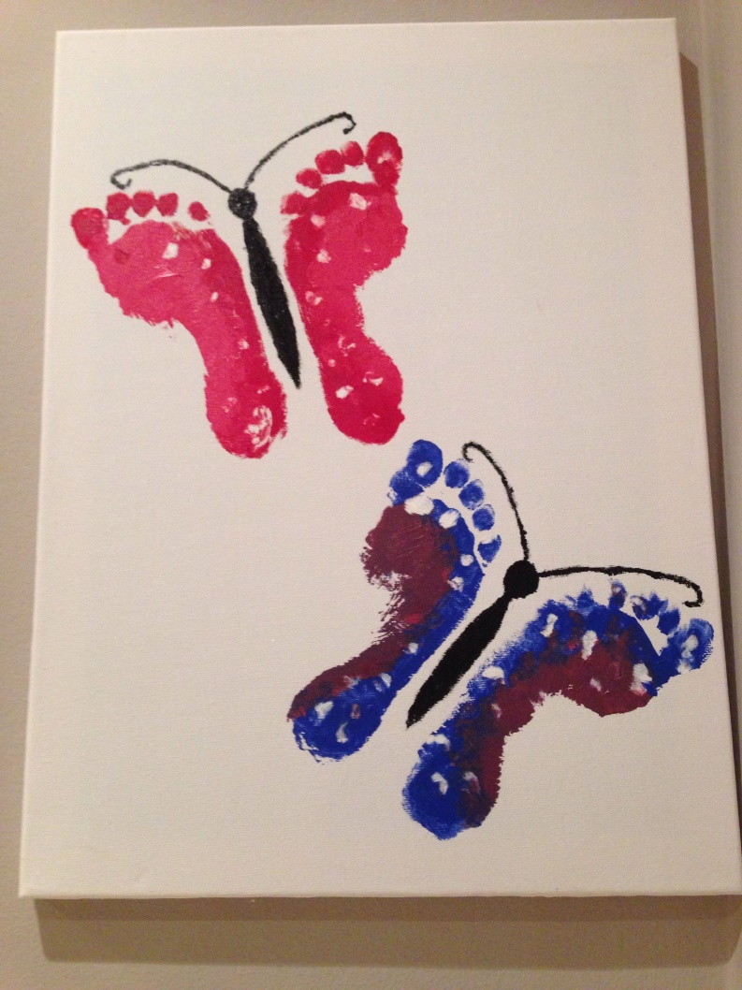

**Outdoors**

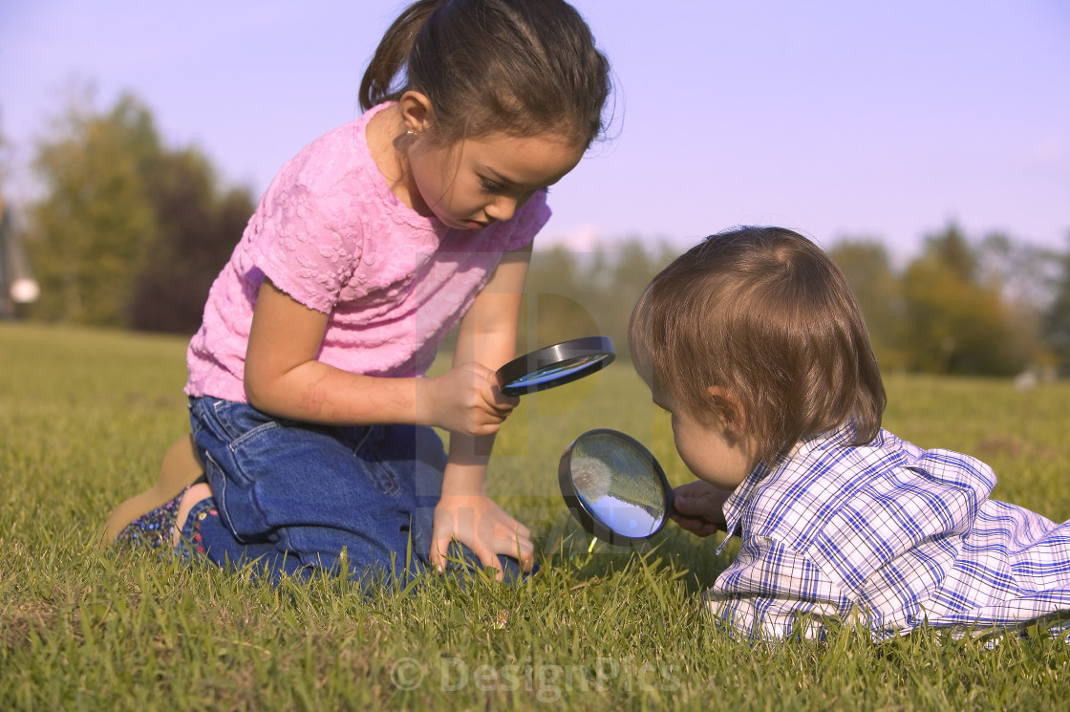Start by watching the video<https://www.youtube.com/watch?v=a8xgh2H5dGw> We would love you to go outside and explore! Look up and down and under logs and see what you can find. You can draw/paint a picture of anything you discover.

**PE**

Have a go at joining in with the Minibeast dance, it’s lots of fun!

<https://www.youtube.com/watch?v=hUbYq93cYdE>

**PSWBCD**

This week can your child make contact with a friend from Nursery? This could be a zoom chat or a phone call or maybe even a social distancing get together. Can your child draw a picture or make something to give/send to their friend.

**Ongoing activities**

* Practise writing their name
* Can children talk about the sounds at the start of the word? Recap on the letter sounds we have covered so far i, t, u, j, y, r, n, m, p, c, a, d, j, q and o
* Lots of counting activities, what is 1 more/1 less than a number
* Practise forming numbers 0-10 and then extend to 20
* Encourage your child to put on their own coats and zip them up independently
* Take part in lots of physical activities; playing outside, scooting, skipping, running etc
* Take turns in a family game and play independently
* Practise the welsh phrases/songs we have covered so far:
* Boreda/Prynhawn da (Good morning/afternoon)
* Pwy wyt ti? (Who are you?)
* Sut wyt ti? (How are you?)
* Sut mae’r tywydd heddiw? (What is the weather like?)
* Sawl? (How many?)
* Pa liw? (What colour?)
* Coch- red, melyn – yellow, glas – blue, oren – orange, gwyrdd – green.

**ICT links;**

<https://www.topmarks.co.uk/maths-games/3-5-years/ordering-and-sequencing>

<https://www.phonicsplay.co.uk/Phase1Menu.htm>

<https://www.topmarks.co.uk/english-games/3-5-years/letters-and-sounds>

<https://www.learninggamesforkids.com/preschool-games.html>

<https://www.bbc.co.uk/cbeebies/games/age-and-needs/pre-school>

We hope you are all safe and well and staying positive. We are so excited about our new topic and we hope your child is too! We would just like to say a massive thank you for supporting your child’s learning through these difficult times. We love to see what you’ve been up to so please keep sharing on Seesaw.

We are here to help and support you all at this difficult time, so please get in touch if we can help.

Many thanks,

Mrs Edwards, Mrs Williams and the Nursery team.

What is your Giant called? \_\_\_\_\_\_\_\_\_\_\_\_\_\_\_\_\_\_\_