Week 11 (Wk Commencing 06.07.20)
Text of the week: Daisy Dare by Anita Jeram

Sound of the week: k
What can you find around your house that begins with a k? Can you draw all the items that begin with k that you find? Have a go at writing a k in the air with your finger. Next spread out some salt/flour onto a surface and have a go at forming a k in the ingredient you choose. Please share some pictures on Seesaw with us.
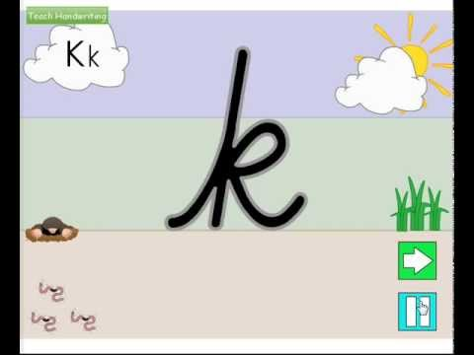

Language
This week our text will be ‘Daisy Dare’ by Anita Jeram. You will be sent a video of the story being read by Mrs Edwards on Monday morning (Seesaw).
Listen to the story, how would you describe Daisy dare? Can you retell the story to a parent or sibling using the pictures below to help you? Once you have practised with someone, could you video yourself describing the start/middle/end of the story for us to watch?

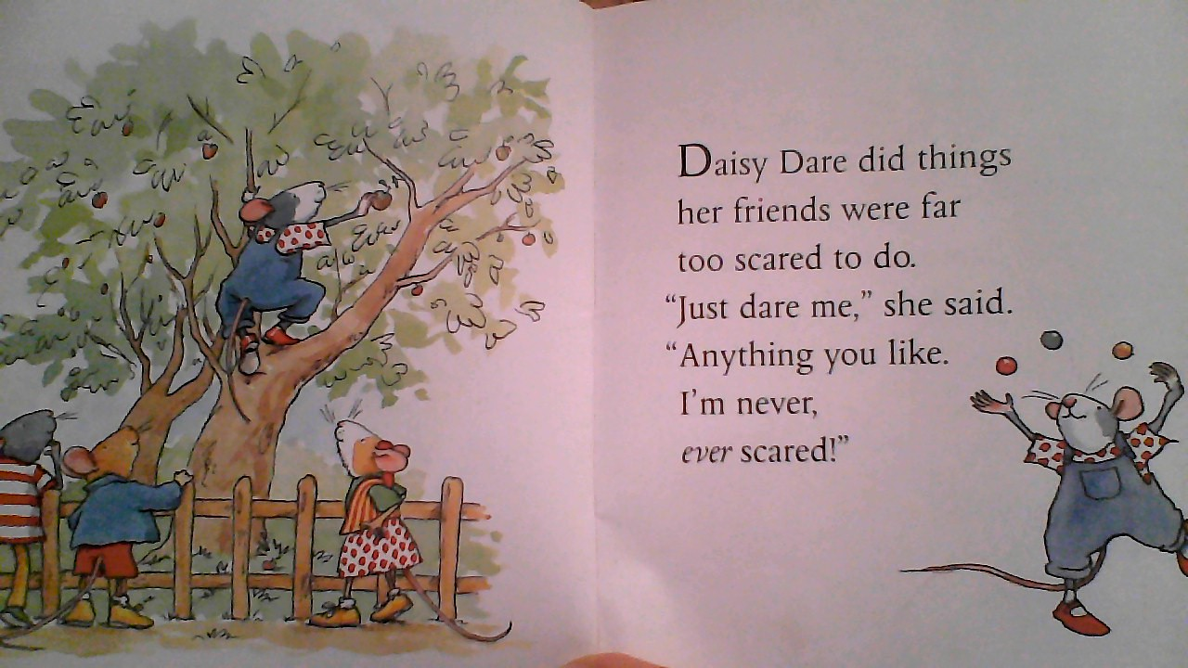

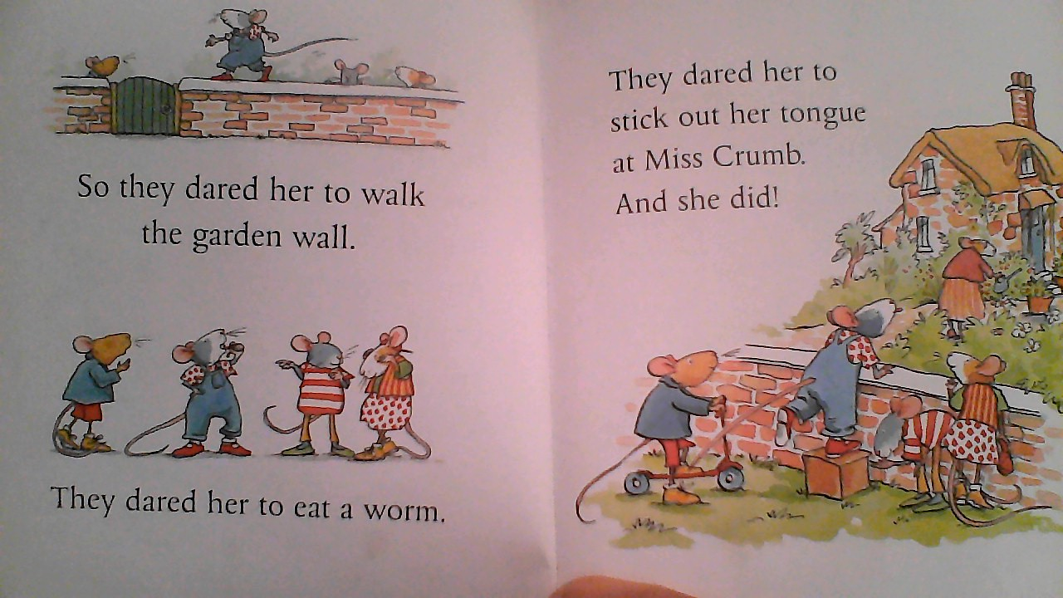

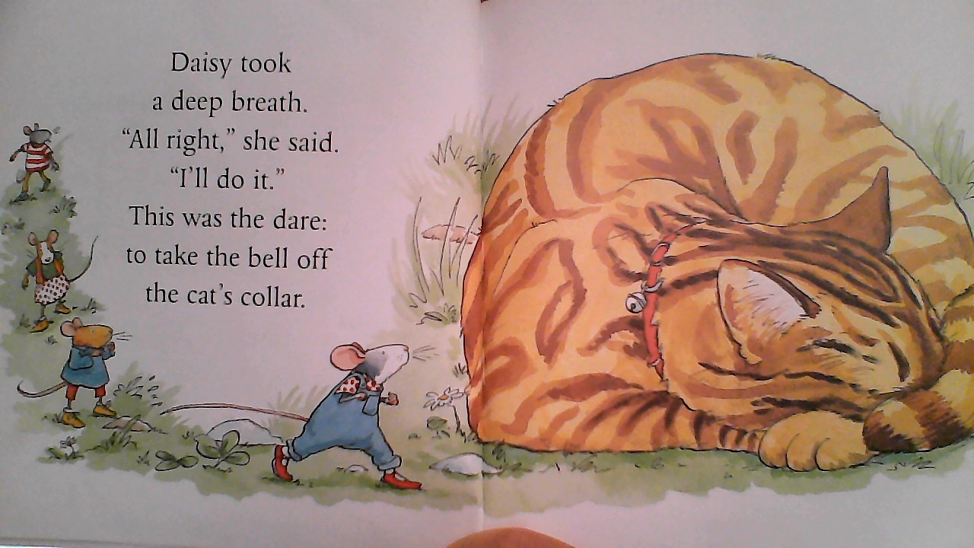

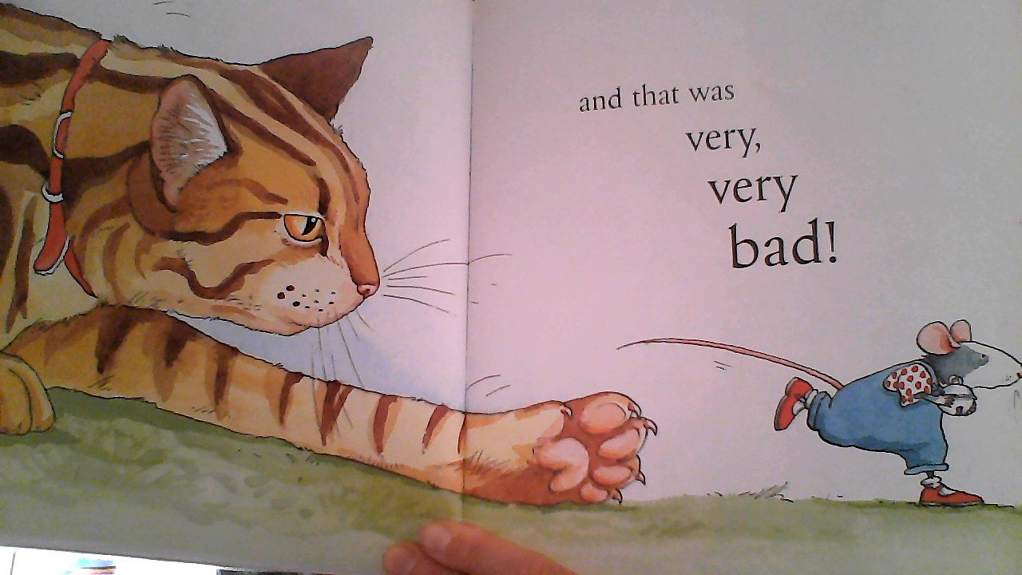

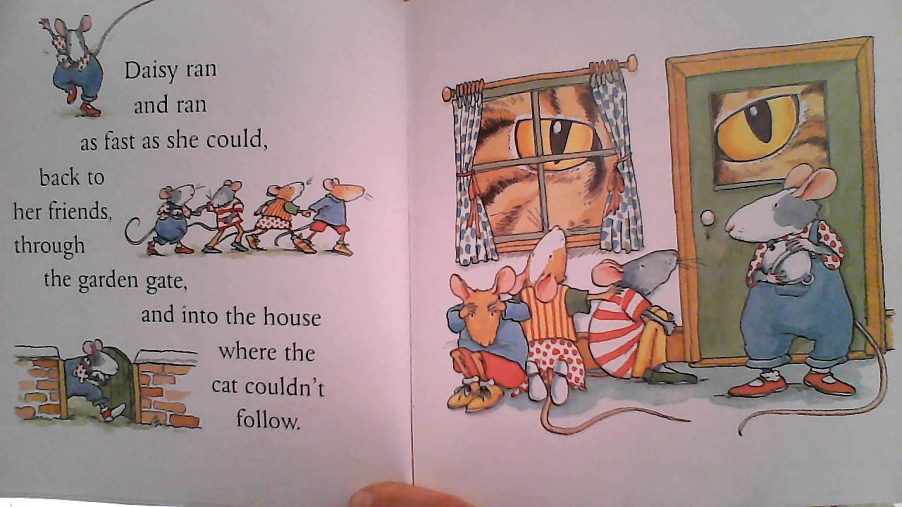

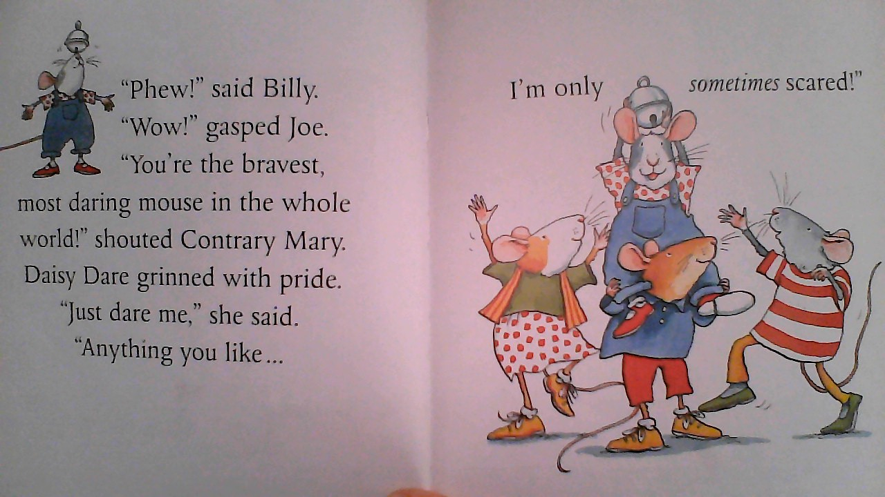

Maths
Can you colour and complete the simple patterns? If you don’t have a printer, you can just draw straight on to paper:

Science
We would like you to find lots of objects from around your house and the sort them into two groups, heavy and light. If you have some scales at home, we would like you to have a go at weighing different objects. Can you draw or photograph your objects when they have been sorted?

Light
Heavy

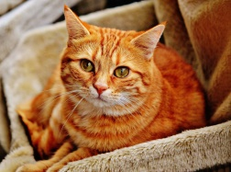

Art and Craft
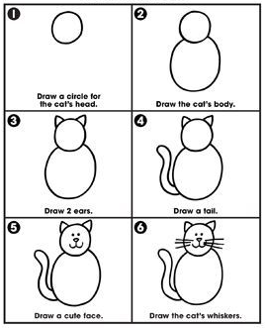
Can you attempt to draw and colour a cat from our story? Please take a photo of the finished picture to share with us on Seesaw.

Outdoors
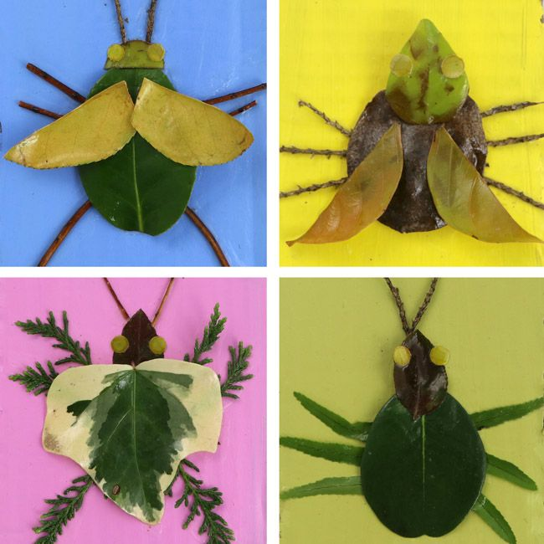
We would like you to go outside and see if you can use any natural materials to create a mini beast. Here are some ideas to inspire you:
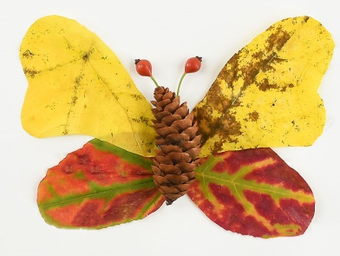

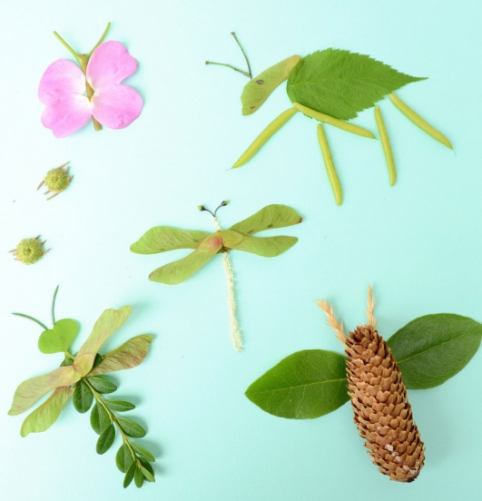

Music
Can you have a go at some of these rhymes? If you learn any, please video and share with us on Seesaw.

Theres a Worm at the Bottom of My Garden

There's a worm at the bottom of my garden
And his name is Wiggly Woo
There's a worm at the bottom of my garden
And all that he can do -
Is wiggle all night
And wiggle all day
Whatever else the people do say;
There's a worm at the bottom of my garden
And his name is Wiggly, Wig-Wig-Wiggly,
Wig-Wig-Wiggly Woo-oo

Two Little Caterpillars
Two little caterpillars sitting on a branch
One called Betty, One called Blanche
Crawl away Betty, crawl away Blanche
Crawl back Betty, crawl back Blanche

Big Bugs Small Bugs
Big bugs, small bugs, big bugs, small bugs
See them crawl, on the wall,
Creepy, creepy, crawling, never, never falling.
Bug, bugs, bugs, bugs, bugs, bugs

Big bugs small bugs
Big bugs, small bugs, big bugs, small bugs
See them crawl, on the wall,
Creepy, creepy, crawling, never, never falling.
Bug, bugs, bugs, bugs, bugs, bugs

Little fuzzy caterpillar
Little fuzzy caterpillar
In your warm cocoon
The cold winter's over and you'll be hatching soon.
Then you'll spread your wings
On a warm summer's day
And wave us all goodbye
As you fly, fly away

Ongoing activities
- Practise writing their name
- Can children talk about the sounds at the start of the word? Recap on the letter sounds we have covered so far i, t, u, j, y, r, n, m, p, c, a, d, j, q, o, l and h
- Lots of counting activities, what is 1 more/1 less than a number
- Practise forming numbers 0-10 and then extend to 20
- Encourage your child to put on their own coats and zip them up independently
- Take part in lots of physical activities; playing outside, scooting, skipping, running etc
- Take turns in a family game and play independently
- Practise the welsh phrases/songs we have covered so far:
- Boreda/Prynhawn da (Good morning/afternoon)
- Pwy wyt ti? (Who are you?)
- Sut wyt ti? (How are you?)
- Sut mae’r tywydd heddiw? (What is the weather like?)
- Sawl? (How many?)
- Pa liw? (What colour?)
- Coch- red, melyn – yellow, glas – blue, oren – orange, gwyrdd – green.

ICT links;
https://www.topmarks.co.uk/maths-games/3-5-years/ordering-and-sequencing
https://www.phonicsplay.co.uk/Phase1Menu.htm
https://www.topmarks.co.uk/english-games/3-5-years/letters-and-sounds
https://www.learninggamesforkids.com/preschool-games.html
https://www.bbc.co.uk/cbeebies/games/age-and-needs/pre-school

We hope you enjoy this week’s activities. We would love to see what your child gets up to so please share your photos on Seesaw.
We are very much looking forward to seeing some of the children back in Nursery next week. If your child is feeling anxious about returning, please have a go at the activity below and bring in with you for your session.
Many thanks,
Mrs Edwards, Mrs Williams and the Nursery team.

What is your Giant called? ___________________

