Week 1

Monday 29th – Friday 3rd July 2020

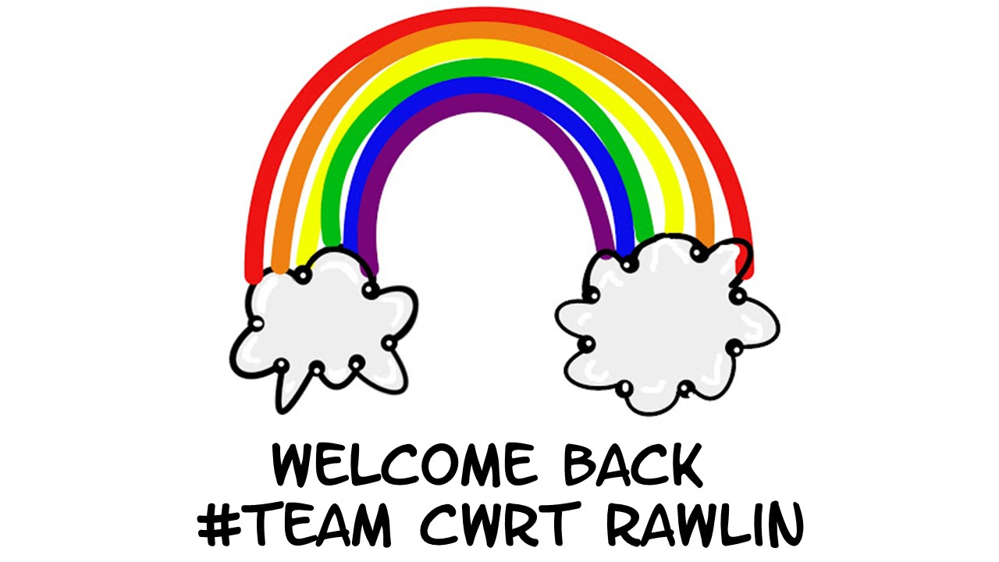
Class 4O

Overview
Week 1: Monday 29th June – Friday 3rd July
Focus/Topic: Preparing for Change
 | Well-being | DCF | Language | Maths
Class Tasks | ‘Check In’  Share experiences.  Complete Good day/Bad day during lockdown.  Reflection of Lockdown Art | Accessing Hwb, Teams, OneDrive – Address difficulties. | What does a good set of instructions look like? Look at model, highlight features. | Addition & Subtraction – review methods and address any difficulties.
Follow up tasks to be completed at home. | How can you be kind to yourself? – worksheet  How many ways can you think of? | Complete the language task at home and upload to One Drive/work online  *See powerpoint of instructions | -Write instructions to build a den  -Reading comprehension online  -Spelling words from list | My Maths  Addition and subtraction practice.

Well-being – Class Task
Discussion – Share experiences of lock down. What have been the challenges? How have we adapted to the changes? Who and what have been a source of support?
Task – Describe what a good day during lockdown looks / feels like and what a bad day during lockdown has been like.
Good Day | Bad Day
How I can make a ‘bad day’ better:
Well-being – Home Task
Complete the ‘How Can You Be Kind to Yourself?’
We often think about how we can be kind to others and what effect our behaviour has on other people.
Have you ever thought about how you can be kind to yourself? Using the hearts below, write your own ideas about how you can be kind to yourself. Some ideas have been given to start you off.
Once you have recorded these ideas, start to think about how you can carry out these ideas to be kind to yourself.

Eat healthily
Be brave

Be positive
Choose kind friends

Get enough sleep
Remember to laugh

Language – Class Task
Discussion
What is the purpose of an instruction text?
Why is it important that instructions are direct, specific and clear?
What could happen if the instructions are unclear or misleading?

Task
Look at the example instructions text. What features can you identify?
How to Make Tissue Paper Poppies
What you will need:
- One sharp pencil
- A pair of scissors
- A pipe cleaner
- A circular container or template
- Red tissue paper
- Black or brown tissue paper
- White craft glue

What to do:

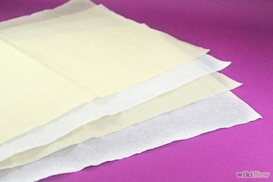 | 1. Lay three pieces of red tissue paper on your work surface. Use additional layers of tissue paper if you want a fuller poppy. Make sure the paper is flat otherwise you will not be able to draw on it. We use red paper because the petals are this colour.
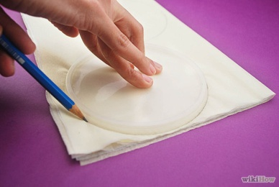 | 2. Secondly, put a round plastic lid, such as a lid from crisp container, on top of the folded tissue paper. Check your pencil is sharp before you begin drawing. Trace around the lid slowly with a pencil. Use scissors to cut out the circle.
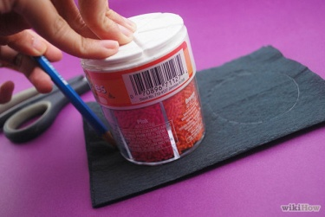 | 3. Next, lay three pieces of black or brown tissue paper on your table. Use a small cup or another object about 5cm in diameter as a pattern. Carefully draw around the circle, then cut out the black tissue paper.
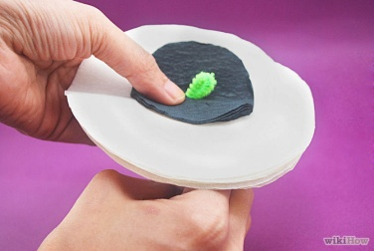 | 4. After that place the stack of small black circles on the centre of the stack of larger circles. Poke a green pipe cleaner up through the middle of the stack while holding the paper firmly. Leave about 2cm of pipe cleaner extending above the paper.
 | 5. Gently bend the pipe cleaner down in a hook shape then pull the bent part of the pipe cleaner through the paper so the hook is hidden in the poppy. Secure the pipe cleaner to the paper poppy with a small amount of white craft glue.
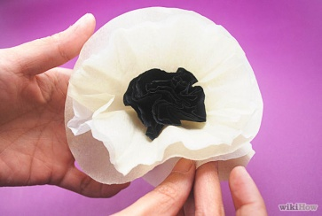 | 6. As soon as the glue is dry, spread the layers of tissue paper to make a ruffled poppy. You mustn’t let the paper become too scrunched because it won’t look like petals anymore.
 | 7. Finally, put a sticker with your name on it at the bottom of the pipe cleaner. Repeat the steps for each tissue paper flower you wish to make.

One final top tip: Tissue paper can rip easily so make sure you handle it with care.

5. Gently bend the pipe cleaner down in a hook shape then pull the bent part of the pipe cleaner through the paper so the hook is hidden in the poppy. Secure the pipe cleaner to the paper poppy with a small amount of white craft glue.
6. As soon as the glue is dry, spread the layers of tissue paper to make a ruffled poppy. You mustn’t let the paper become too scrunched because it won’t look like petals anymore.
7. Finally, put a sticker with your name on it at the bottom of the pipe cleaner. Repeat the steps for each tissue paper flower you wish to make.

One final top tip: Tissue paper can rip easily so make sure you handle it with care.

Note the features you find and give examples from the text:

Features of an instruction text

Language – Home Task
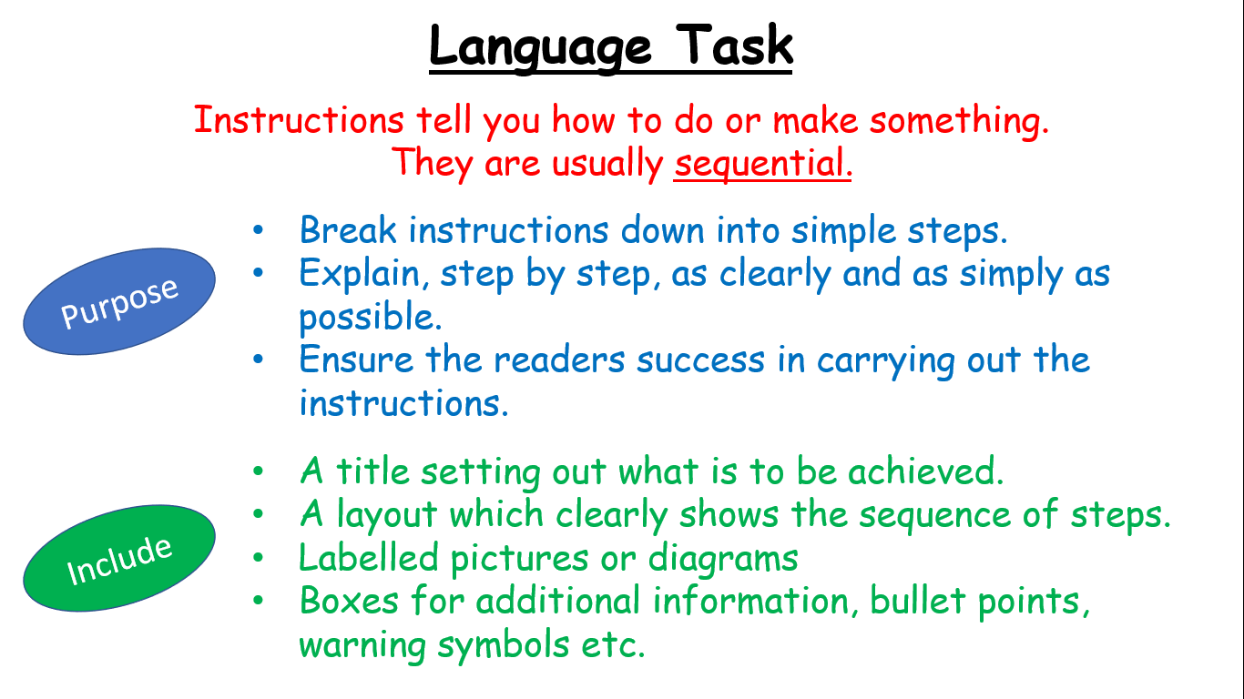

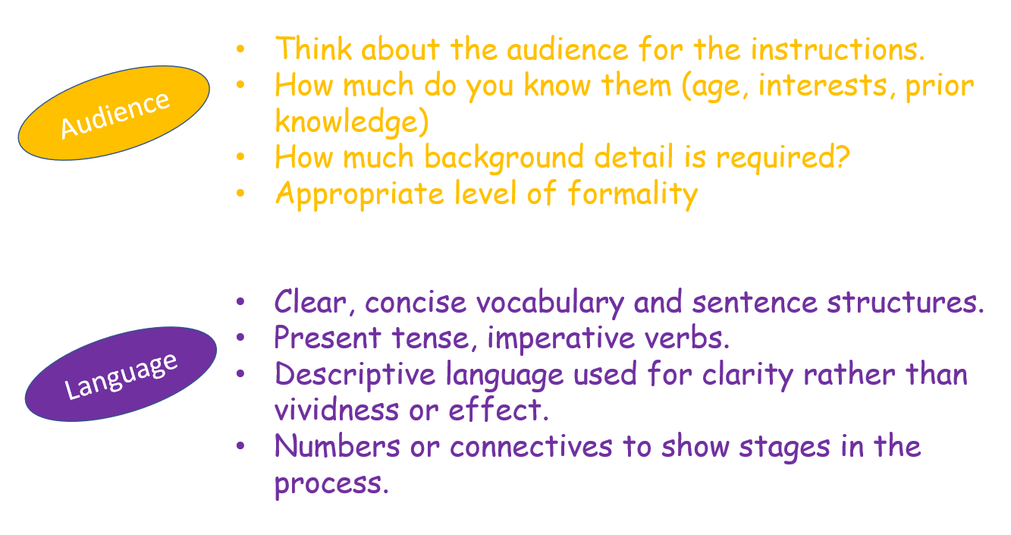

Include these features in your own set of instructions.

Task - Write instructions on How to build a den – this can be indoors or outdoors.
If possible build the den first!

Log in to Hwb – Office 365 – OneDrive – Choose your folder – New – word document - *See Powerpoint of instructions on Website page – Save/rename your document.

Maths – Class Task
Revision of methods to add and subtract.

Maths – Home Task
Choose at least 4 addition sums and 4 subtraction sums to complete.
* | ** | *** | ****
32 + 21 = | 99 + 37 = | 734 + 317 = | 462 + 332 =
65 + 33 = | 94 + 23 = | 498 + 125 = | 562 + 331 =
59 +17 = | 88 + 39 = | 785 + 283 = | 1345 + 423 =
99 + 37 = | 748 + 83 = | 264 + 124 = | 2456 + 298 =
64 + 23 = | 462 + 39 = | 422 + 309 = | 7462 + 389 =
100 + 57 = | 634 + 96 = | 538 + 396 = | 7634 + 3396 =
45 + 21 = | 523 + 45 = | 523 + 453 = | 4523 + 4050 =
52 + 18 = | 864 + 58 = | 864 + 358 = | 9864 + 5682 =
32 + 16 = | 345 + 123 = | 1345 + 423 = | 7345 + 4123 =

* | ** | *** | ****
32 – 21 = | 99 – 37 = | 734 – 317 = | 462 – 3=32 =
65 – 33 = | 94 – 23 = | 498 – 125 = | 562 – 331 =
59 – 17 = | 88 – 39 = | 785 – 283 = | 1345 – 423 =
99 – 37 = | 748 – 83 = | 264 – 124 = | 2456 – 298 =
64 – 23 = | 465 – 39 = | 422 – 309 = | 7462 – 389 =
99 – 33 = | 634 – 96 = | 538 – 396 = | 7634 – 3396 =
100 – 57 = | 523 – 45 = | 523 – 453 = | 4523 - 4050
45 – 21 = | 864 – 58 = | 864 – 358 = | 9864 - 5682=
52 – 18 = | 345 – 123 = | 1345 – 423 = | 7345 - 4123 =
32 – 16 = | 456 – 298 = | 2456 – 298 = | 6456 - 3298=

*Don’t forget your My Maths task!

