Please find below some extra activities linked to ‘The Great Outdoors’ You may think of other ideas and other activities linked to the topic, please access what’s appropriate for you and let me know if you would like other information. We are guided to avoid worksheets and encourage children to choose how to present their work i.e paper task, homework book, online, word, powerpoint, videos etc
Literacy task –
Write a story – choose one of the following titles:  ‘The Great Escape’  ‘The noise behind the shed’  ‘A Walk in the Woods’  *Remember to plan first – introduction, character, setting, main events, problem and resolution.  *Remember to use good sentence starters, good vocabulary, paragraphs and punctuation.  See links below to ISPACED and Higher level vocabulary – link on homework page, website | 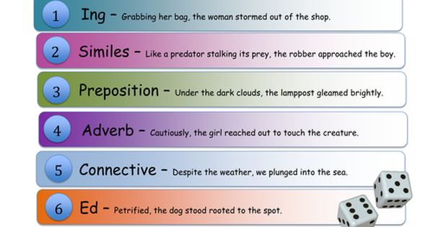
Maths task -
Plan a party! What will you need? Think of creating lists for food and drinks, paper plates, cups, party games, equipment! Look on websites for costs of items.  Add all of the total costs!  Extra - *Ask your parents for a budget to work from (they might say you’ve got a budget of £200 to spend!)  Extra challenge - *If you can, keep a track of all costs on a spreadsheet and use formulae to find totals of quantities.  Also link below and on website to worksheet if preferred. | 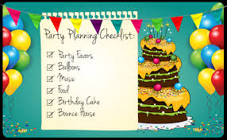
Thematic tasks
Design a garden or park! Draw a plan of your garden or an imaginary garden. Will you have grass? Patio? Plants? Trees? Decking? Play equipment? Swimming pool? Be creative!
Draw your plan from a birds eye view –
See powerpoint below or link on website

Literacy task links -
ISPACED -

Higher level vocabulary – link on website homework page in case this link doesn’t work!
Numeracy task links

*link on homework page on website
Design a garden or park – powerpoint on website!

Don’t forget –
- Mymaths – x3 per week
- Reading and spelling – daily/frequently
- Reading comprehension
- Revisions of times tables
- Hwb – great resources here – J2Easy + Office 365 + Adobe Spark!

See you all soon!

Miss Owen

