PLEASE DO NOT TAKE FOR GRANTED HOW IMPORTANT THESE WORDS ARE TO GET RIGHT.
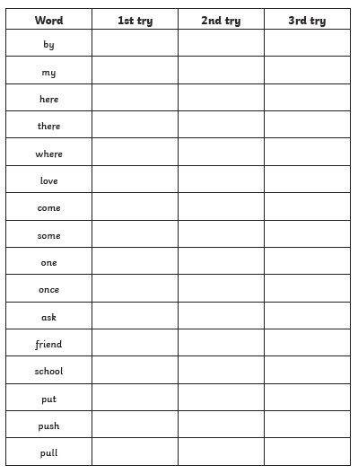
EXTTRA CHALLENGE: PUT 5 OF THESE WORDS INTO SENTENCES USING JOINED UP HANDWRITING.

