THE ZOO VET
READING COMPREHENSION
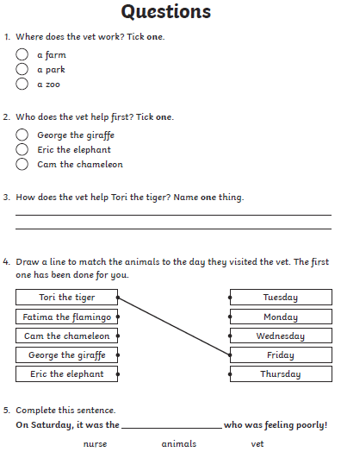
YOU WILL NEED TO READ THE EBOOK, ‘THE ZOO VET’ BEFORE ANSWERING THESE QUESTIONS.

