STOP TELLING FIBS
READING COMPREHENSION
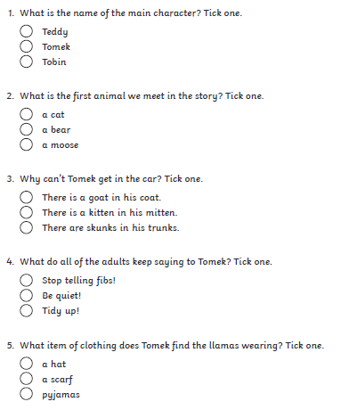
YOU WILL NEED TO READ THE EBOOK, ‘STOP TELLING FIBS’ BEFORE ANSWERING THESE QUESTIONS.

