Week 1

Monday 29th – Friday 3rd July 2020

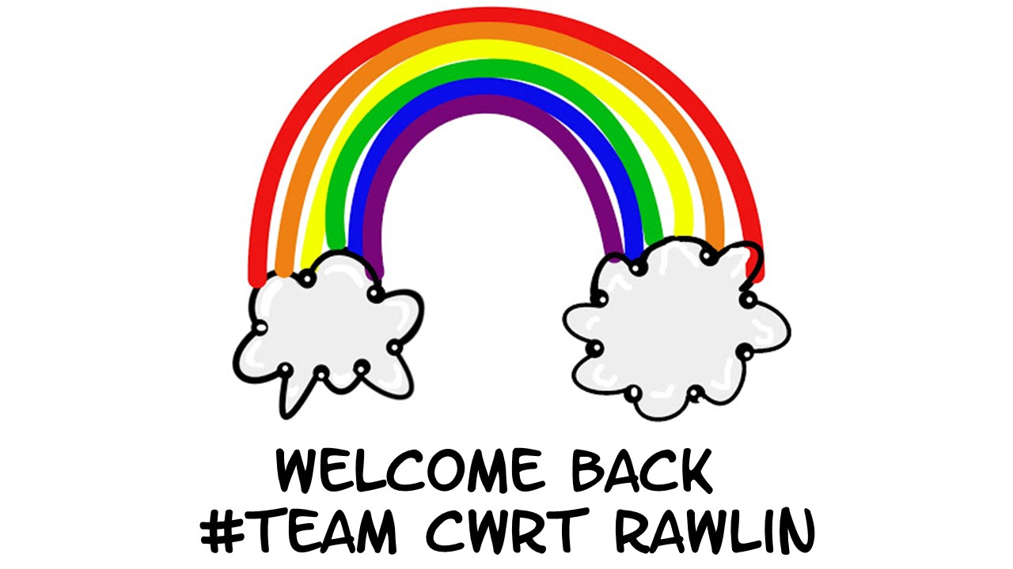
Year 6

Overview
Week 1: Monday 29th June – Friday 3rd July
Focus/Topic: Preparing for Change
 | Well-being | DCF | Language | Maths
Class Tasks | ‘Check In’  Share experiences.  Complete Good day/Bad day during lockdown.  Reflection of Lockdown Art | Access Hwb, Teams, OneDrive. Review how to upload. Address difficulties. | What does a good set of instructions look like? Look at model, highlight features. | Addition & Subtraction – review methods and address any difficulties.
Follow up tasks to be completed at home. | Reflections on highs and lows over the lockdown period. Complete a ‘Feelings Graph’. | Log into Hwb. Create new document in  Office 365.  Upload Language task to OneDrive. | Write own instructions.  Spellings  Reading comprehension | My Maths  Addition and subtraction practice.

Well-being – Class Task
Discussion – Share experiences of lock down. What have been the challenges? How have we adapted to the changes? Who and what have been a source of support?
Task – Describe what a good day during lockdown looks / feels like and what a bad day during lockdown has been like.
Good Day | Bad Day
How I can make a ‘bad day’ better:
A Reflection of Lockdown
Art
Draw and cut out a heart shape and paint it to create a rainbow effect.

Brainstorm words to describe your lockdown experience and add them to your heart painting .

Well-being – Home Task
Reflect on your time during lockdown. What have been the highs and lows? Talk to a grown up and reflect on the past weeks while we have been away from school.
Complete the Feelings graph. Use a X to plot how you felt at the start of lockdown, in the middle of lockdown and now. Join the crosses to form a line graph.
Now
At the start of lockdown
In the middle of lockdown
Sad
Upset
Excited
Happy
Frustrated
Fed up
OK
content

Language – Class Task
Discussion
What is the purpose of an instruction text?
Why is it important that instructions are direct, specific and clear?
What could happen if the instructions are unclear or misleading?

Task
Look at the example instructions text. What features can you identify?
How to Make Tissue Paper Poppies
What you will need:
- One sharp pencil
- A pair of scissors
- A pipe cleaner
- A circular container or template
- Red tissue paper
- Black or brown tissue paper
- White craft glue

What to do:

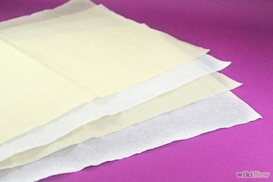 | 1. Lay three pieces of red tissue paper on your work surface. Use additional layers of tissue paper if you want a fuller poppy. Make sure the paper is flat otherwise you will not be able to draw on it. We use red paper because the petals are this colour.
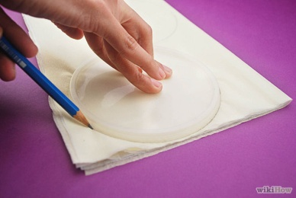 | 2. Secondly, put a round plastic lid, such as a lid from crisp container, on top of the folded tissue paper. Check your pencil is sharp before you begin drawing. Trace around the lid slowly with a pencil. Use scissors to cut out the circle.
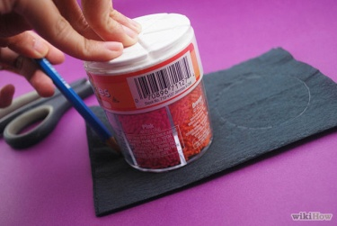 | 3. Next, lay three pieces of black or brown tissue paper on your table. Use a small cup or another object about 5cm in diameter as a pattern. Carefully draw around the circle, then cut out the black tissue paper.
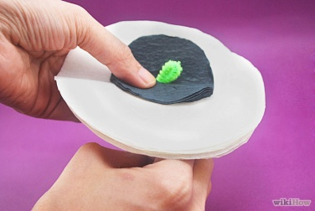 | 4. After that place the stack of small black circles on the centre of the stack of larger circles. Poke a green pipe cleaner up through the middle of the stack while holding the paper firmly. Leave about 2cm of pipe cleaner extending above the paper.
 | 5. Gently bend the pipe cleaner down in a hook shape then pull the bent part of the pipe cleaner through the paper so the hook is hidden in the poppy. Secure the pipe cleaner to the paper poppy with a small amount of white craft glue.
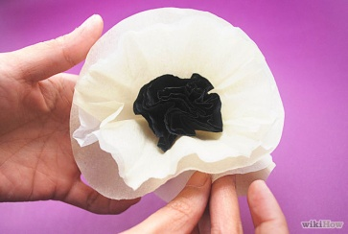 | 6. As soon as the glue is dry, spread the layers of tissue paper to make a ruffled poppy. You mustn’t let the paper become too scrunched because it won’t look like petals anymore.
 | 7. Finally, put a sticker with your name on it at the bottom of the pipe cleaner. Repeat the steps for each tissue paper flower you wish to make.

One final top tip: Tissue paper can rip easily so make sure you handle it with care.

5. Gently bend the pipe cleaner down in a hook shape then pull the bent part of the pipe cleaner through the paper so the hook is hidden in the poppy. Secure the pipe cleaner to the paper poppy with a small amount of white craft glue.
6. As soon as the glue is dry, spread the layers of tissue paper to make a ruffled poppy. You mustn’t let the paper become too scrunched because it won’t look like petals anymore.
7. Finally, put a sticker with your name on it at the bottom of the pipe cleaner. Repeat the steps for each tissue paper flower you wish to make.

One final top tip: Tissue paper can rip easily so make sure you handle it with care.

Note the features you find and give examples from the text:

Features of an instruction text

Language – Home Task
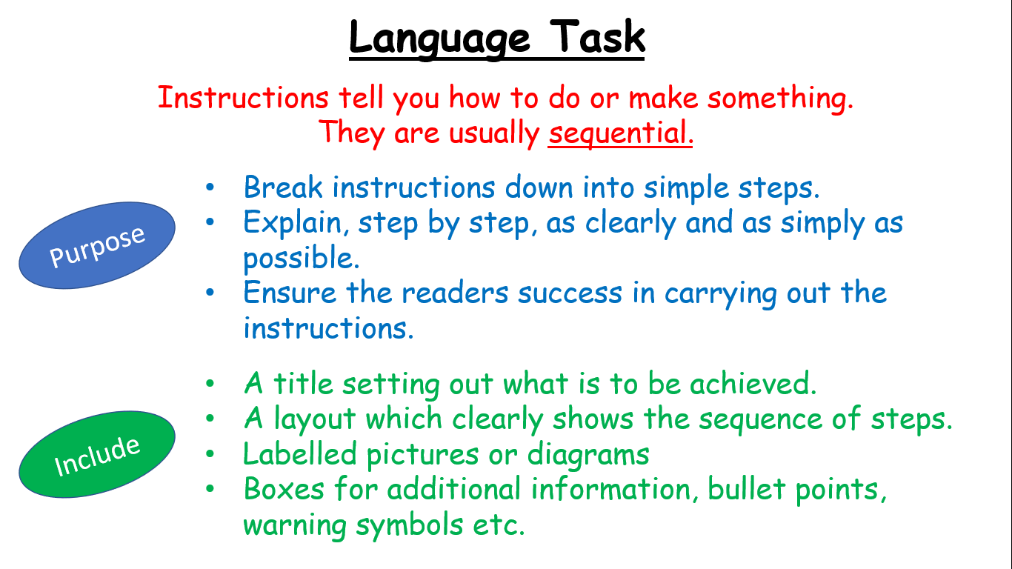

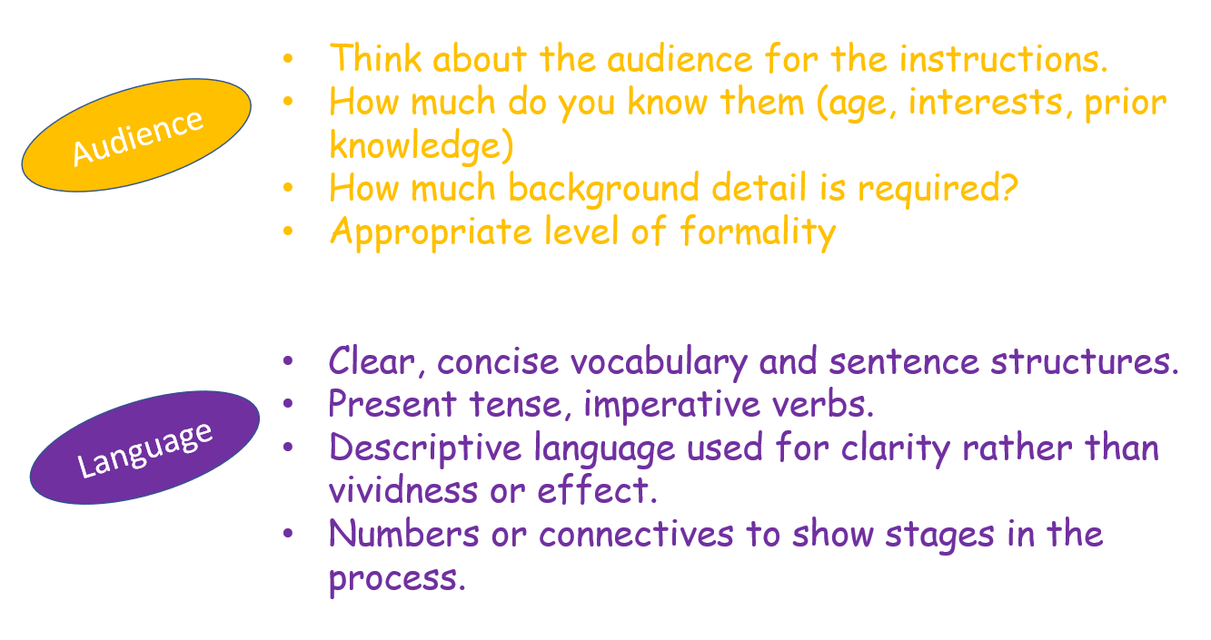

Include these features in your own set of instructions.

Choose from one of the following choices.

Write instructions for:
- How to put on a school tie.
- Directions from home to your new high school.
- How to send an email with an attachment.
- How to prepare for the first day of high school.
- How to make new friends.
- How to ride a bike

Type your instructions on to a blank Word document.

Look at the ‘How to share work with my teacher’ help sheet and upload the document to our class One Drive.

Maths – Class Task
Discussion
Which My Maths tasks have we enjoyed the most?
Which tasks have caused the most difficulty?
Which maths concepts do we most want to revisit?

Warm up – ordering decimal numbers

Task – Column Addition and Subtraction.
Roll a dice to generate a number and complete the addition sums.
Make sure the columns are lined up correctly.
* | ** | ***
4 digit + 3 digit = | 4 digit + 4 digit = | 5 digit + 4 digit =
E.g. 2456 + 298 = | 7345 + 4123 = | 97345 + 4123 =
1dp + 1dp = | 2dp + 2dp = | 3dp + 2dp =
E.g. 23.7 + 47.6 = | 23.37 + 47.26 = | 323.347 + 47.26 =
Repeat for subtraction.

Maths – Home Task

Addition and Subtraction Practice.
* | ** | ***
1) 7299 + 307 = | 1) 6864 + 682 = | 1) 9864 + 5682 =
2) 9294 + 213 = | 2) 7345 + 423 = | 2) 7345 + 4123 =
3) 2988 + 739 = | 3) 6456 + 3798 = | 3) 62456 + 3298 =
4) 74.8 + 87.3 = | 4) 8.43 + 3.58 = | 4) 8.643 + 3.58 =
5) 46.2 + 3.9 = | 5) 13.45 + 4.23 = | 5) 13.45 + 4.203 =
6) 63.4 + 9.6 = | 6) 2.45 + 21.98 = | 6) 2.456 + 29.98 =
1) 462 - 39 = | 1) 422 - 309 = | 1) 7462 - 389 =
2) 634 – 96 = | 2) 538 – 396 = | 2) 7634 – 3396 =
3) 523 – 45 = | 3) 5.23 – 4.53 = | 3) 45.23 – 4.050 =
4) 86.4 – 5.8 = | 4) 86.4 – 35.8 = | 4) 98.64 – 5.682 =
5) 34.5 – 12.3 = | 5) 134.5 – 4.23 = | 5) 73.45 – 41.23 =
6) 45.6 – 29.8 = | 6) 245.6 – 29.8 = | 6) 64.564 – 32.98 =

Choose at least 4 addition sums and 4 subtraction sums to complete.

Don’t forget your My Maths task!

