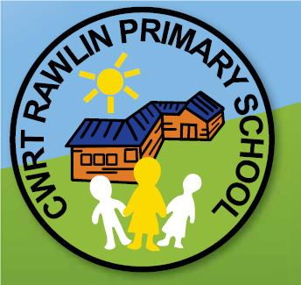

Transition Task 2
Compare Cwrt Rawlin Primary School with St Martins Comprehensive School.
You can choose the way that you set out your comparison. You could use a table, create a PowerPoint presentation, use a Venn diagram or electronically using the ‘Clips’ app or other software.
The links below will help you to get started with your research:

Cwrt Rawlin | St Martins
https://www.cwrtrawlinprimary.co.uk/ | https://www.stmartins.caerphilly.sch.uk/
https://twitter.com/cwrtrawlinprim | https://twitter.com/StMartinsInfo
https://twitter.com/MrJohns_crps | https://www.youtube.com/channel/UC9LnVIgfDgserez2AIkE4MQ

Please submit Transition Task 1 and 2 by 3:30pm on Friday 5th June 2020

