Week 1

Monday 29th – Friday 3rd July 2020

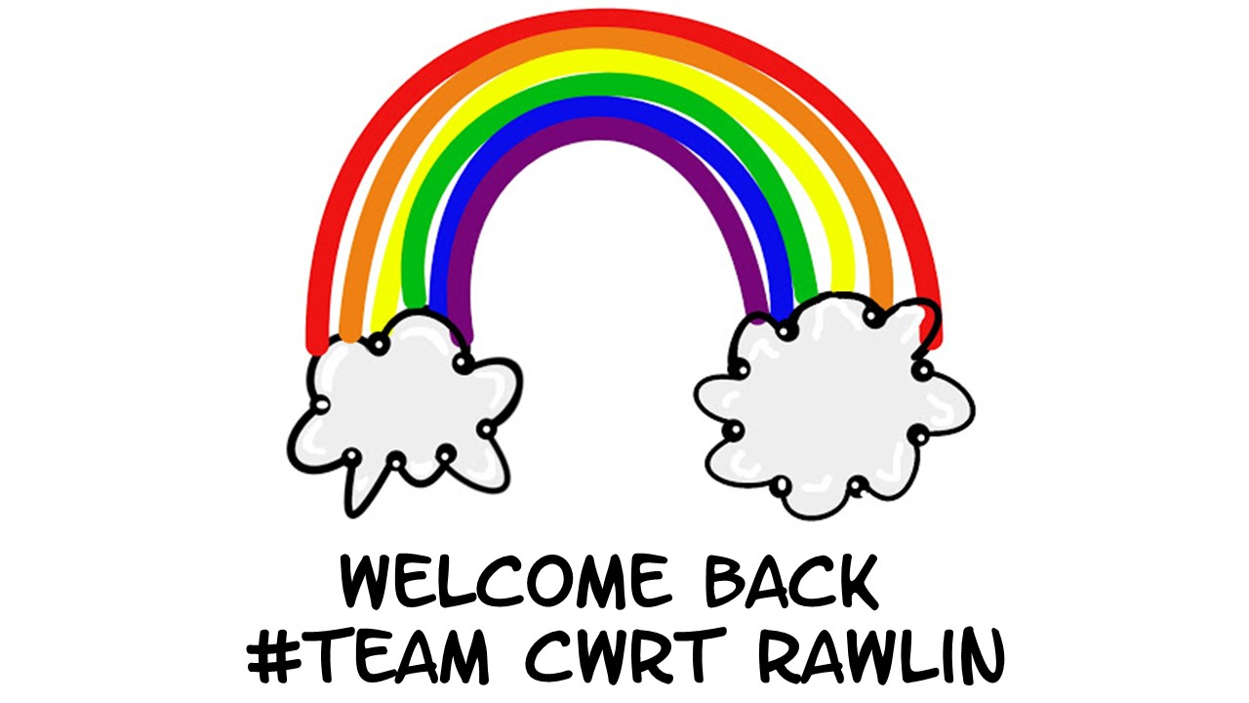
Year 5

Tangram Challenge
https://www.transum.org/software/Tangrams/Template.asp
Instructions:
- Cut out the different coloured shapes very carefully.
- Now, try to put the shapes back together to make some of the silhouetted shapes.
- You must always use all seven shapes.
- The shapes should never overlap one another.
- Can you make any new shapes following these rules?
- Can you make the original square once again?
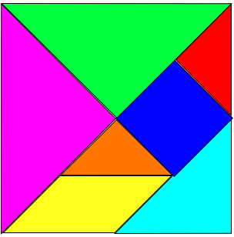

Number Cruncher!

What numbers can you make using:
Note: Every sum needs to have one of each number and any of the operations
e.g. 1 + 2 + 3 – 4 = 2

1 2 3 4
+ - x ÷

0 | 16
1 | 17
2 | 18
3 | 19
4 | 20
5 | 21
6 | 22
7 | 23
8 | 24
9 | 25
10 | 26
11 | 27
12 | 28
13 | 29
14 | 30
15 | Your biggest number is:

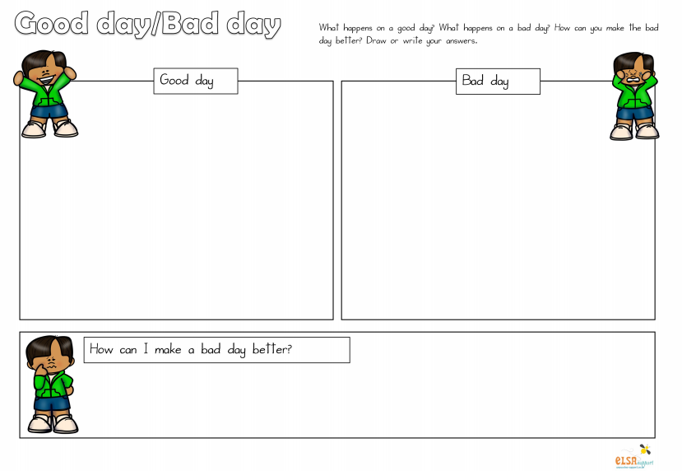
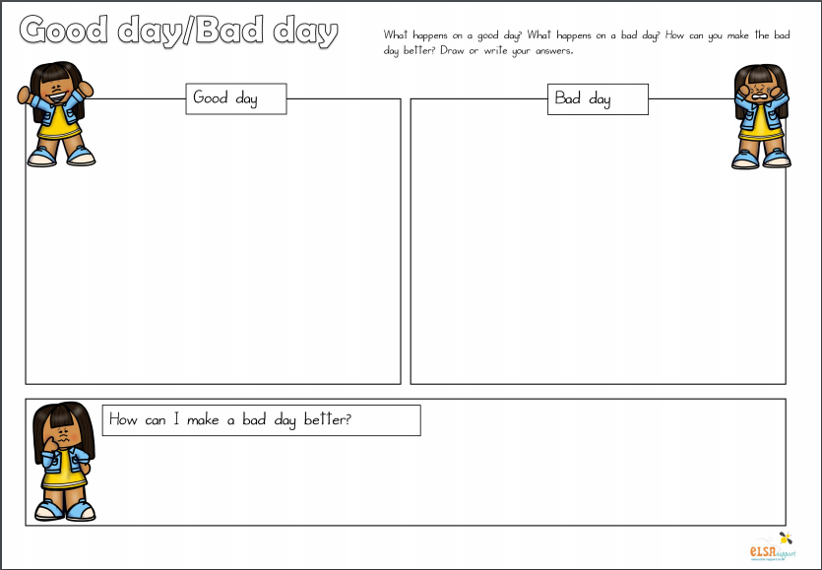
Guide for writing instructions.
