How do I share my work with my teacher?

Option 1: work online

Step 1: Log into Hwb
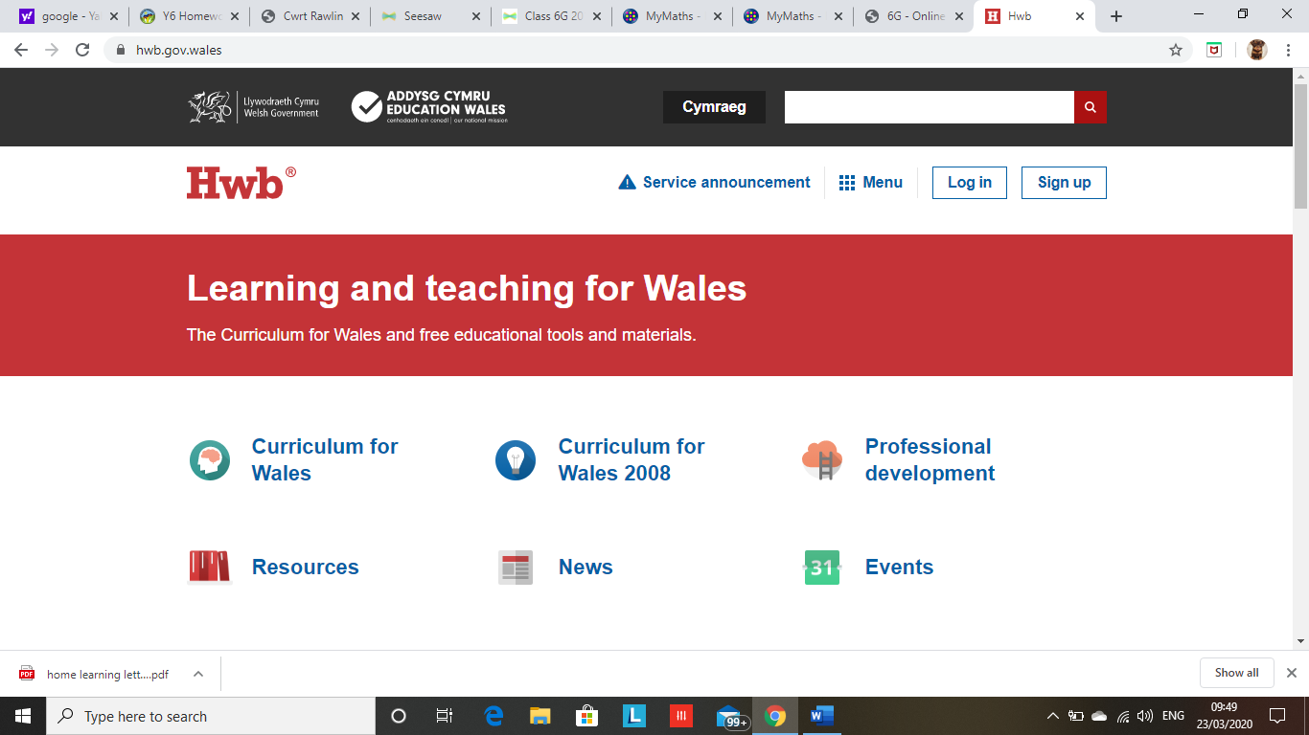

Step 2: Click ‘office 365’
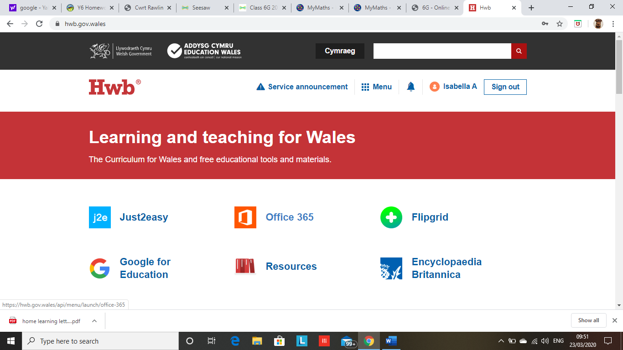

Step 3: Click ‘OneDrive’

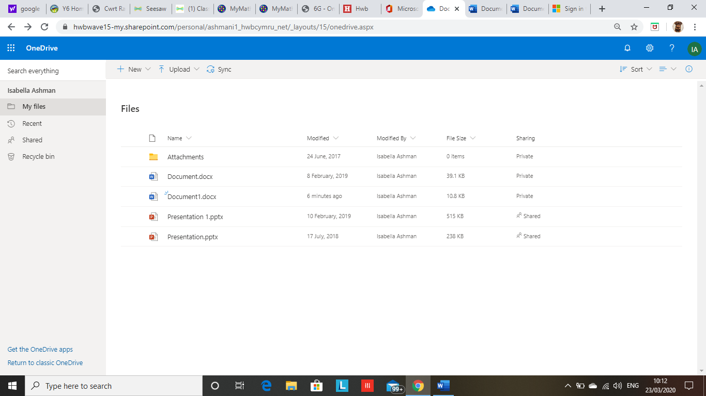
Step 4: Click on ‘Return to Classic OneDrive’ at the bottom of the screen

Step 5: Click on the group named CWRPC_Class56J on the left hand side of the screen.
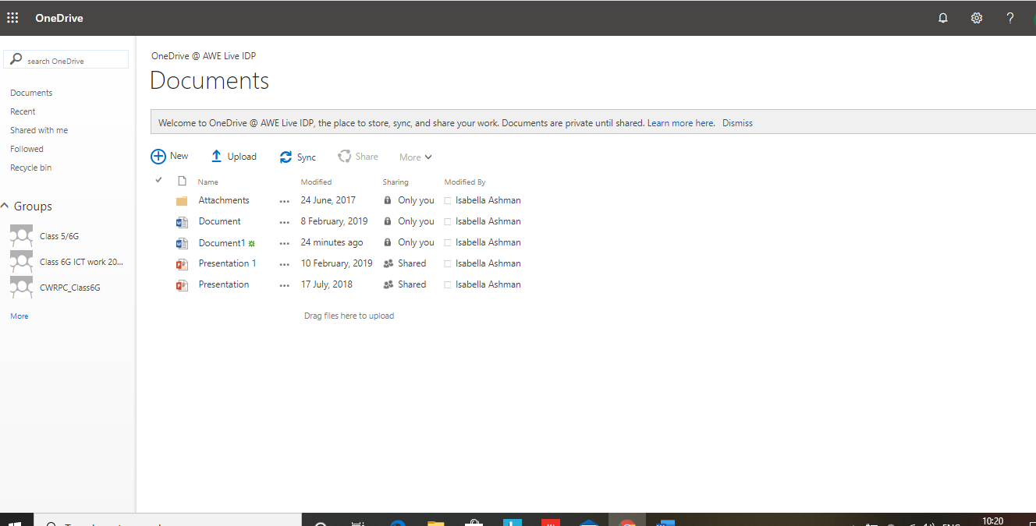

Step 6: Open the folder called ‘Pupil Folders’
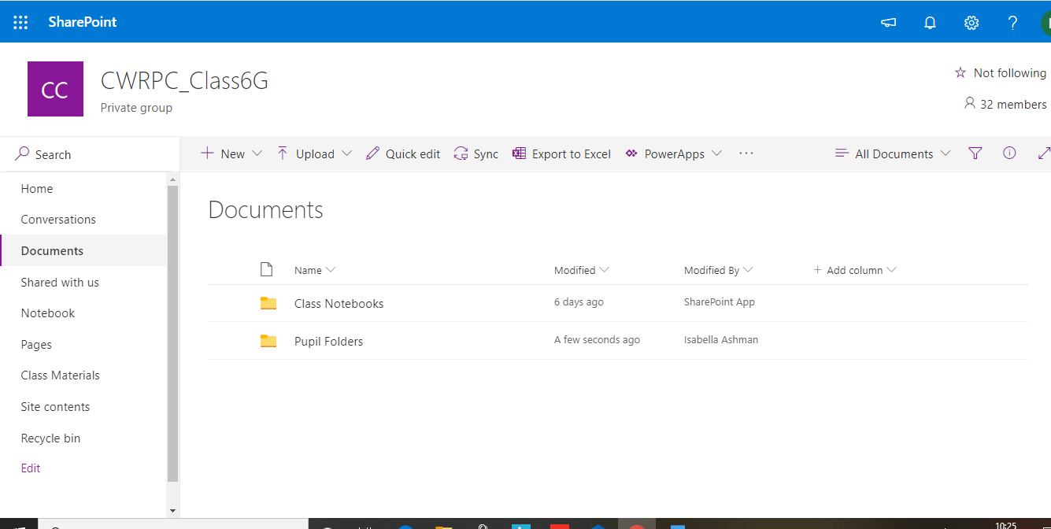

Step 7: Here you will find individual folders for all pupils. Click on your folder only. Please do not access any other folder other than your own.
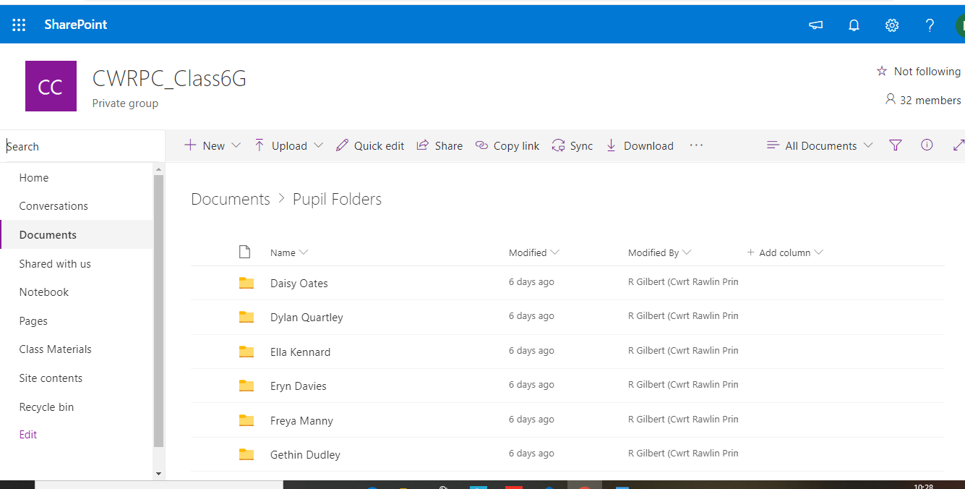

Step 8: Once you have opened your folder, you can then add a new document by clicking on + New
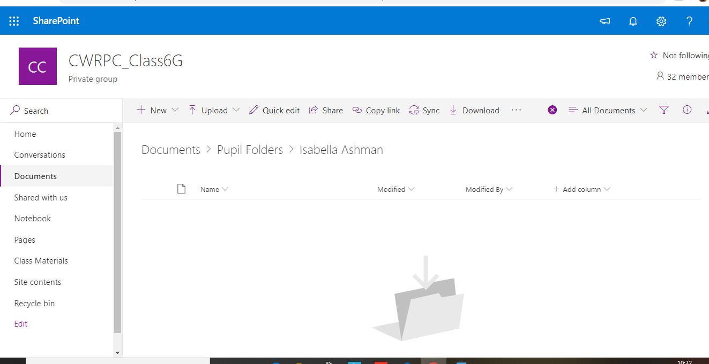

Step 9: Select which programme you would like to work in. E.g. Word, Powerpoint etc
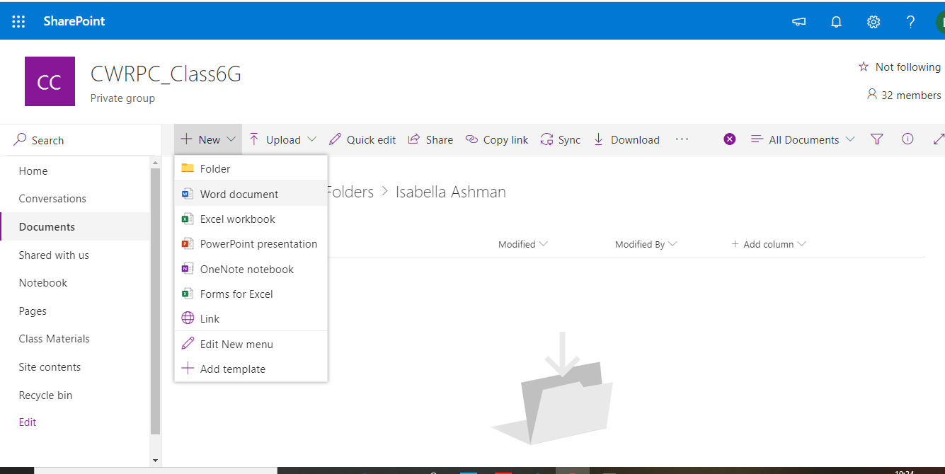

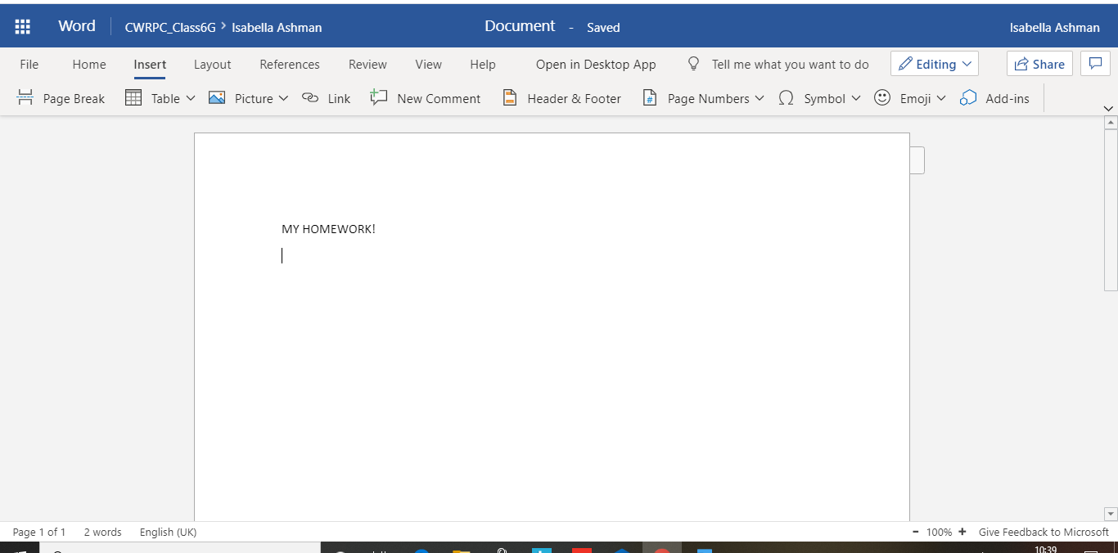
Step 10: Now you have opened a new document to work in, it will save automatically in your folder.

If you wish to take photos of handwritten work or practical / creative tasks, some of the online programmes (Word and PowerPoint for example) have the option to insert a photo or a link to a video. Please ensure any photos are annotated with a brief explanation of what you did and how you did it.
Your teacher will be able to see all work saved into the folder CWRPC_Class56J.
Option 2: Work offline and upload later

Step 1: Create your document offline on your computer desk top. Save your work to your documents on the computer.
Step 2: Log in to Hwb and access OneDrive. Click ‘Return to classic OneDrive’ to find the class folder ‘CWRPC_Class56J’ (See instructions above). Open your folder.
Step 3: Click ‘Upload’
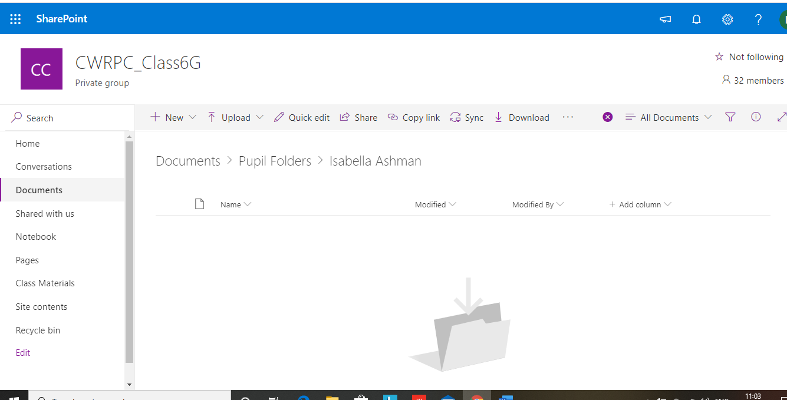

Step 4: Click to upload a file
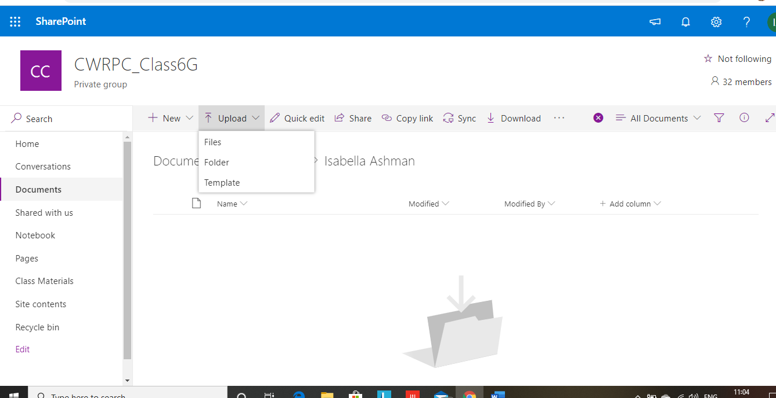

Step 5: Select your work from the documents saved on your computer and click ‘open’
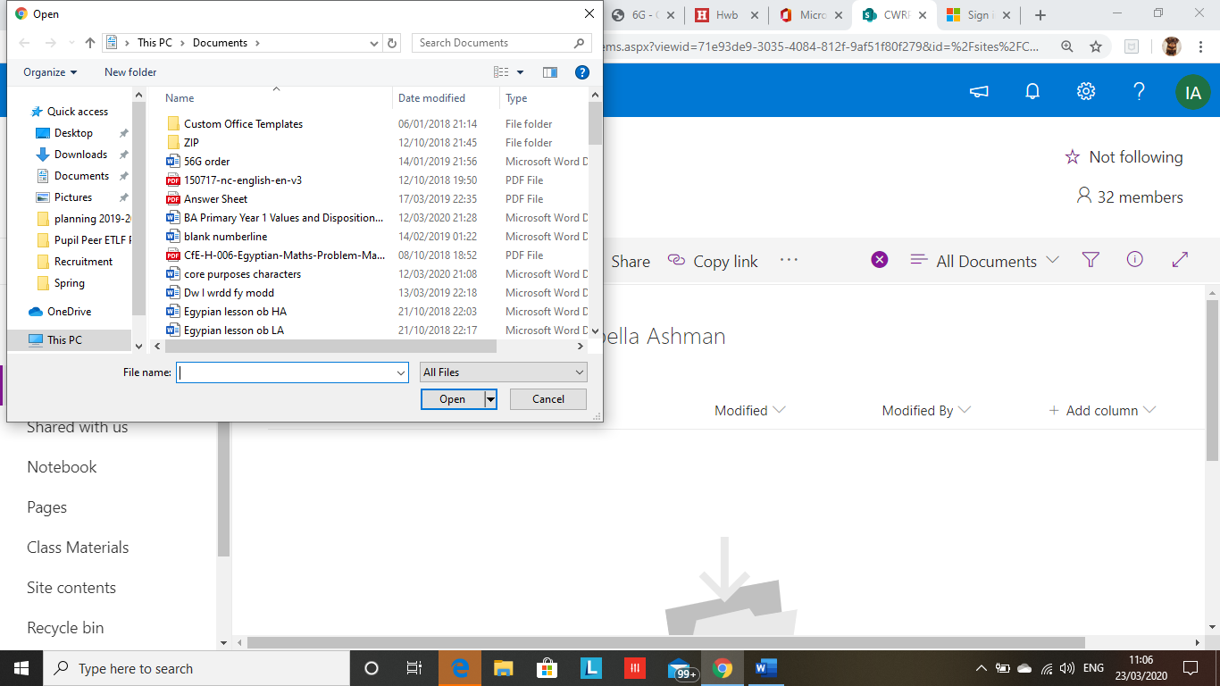

Your work will then save into your folder for your teacher to see.
